**VEDAS COLLEGE**

AFFILIATED TO TRIBHUVAN UNIVERSITY

**JAWALAKHEL, LALITPUR**

B.Sc.CSIT2080





**A**

**Lab Report**

**ON**

**Introduction to Information Technology**

**Subject Code: CSC114**

**Submitted By: Submitted To:**

Prajwal Chaulagain Ishan Timilsina

Semester: B.Sc.CSIT 1st Lecturer

VC80IT17

**Table of Contents**

I. 1. Lab report of IIT on Computer Hardware. 5

1.1 Introduction to Computer Hardware. 5

1.2. Types of Computer Hardware. 5

1. 1.2.1. Internal hardware. 6

2. 1.2.2. External hardware. 8

1.3. How to building a computer. 10

3. 1.3.1. Step 1: Remove Side Panels on Case. 10

4. 1.3.2. Step 2: Insert Motherboard. 11

5. 1.3.3. Step 3: Check Clearances. 12

6. 1.3.4. Step 4: Front Panel Connections. 12

7. 1.3.5. Step 5: Install Power Supply. 13

8. 1.3.6. Step 6: Power Motherboard. 13

9. 1.3.7. Step 7: Installing Optical Drive. 14

10. 1.3.8. Step 8: Installing the Hard Drives. 14

11. 1.3.9. Step 9: Connect Cables. 15

12. 1.3.10. Step 10: Install RAM. 15

13. 1.3.11. Step 11: Install Graphics Card and Expansion Cards. 16

14. 1.3.12. Step 12: Cable Management. 16

15. 1.3.13. Step 13: Final Product. 17

II. 2. Lab report of IIT on the topic of Computer virus and Antivirus. 18

2.1. Opening Microsoft PowerPoint: 19

2.2. To Creating a new blank presentation: 20

2.3. To create a new slide: 21

2.4. To change the font, font size and fond style: 21

2.5. For the text align: 22

2.6. For insert images: 22

2.7. For design: 23

2.8. For transitions: 23

2.9. For the Animations: 23

III. 3. Lab report of IIT on Microsoft Word (MS Word): 24

3.1. Opening Microsoft Word: 24

3.2. To create a new document: 25

3.3. To change the font, font size and font style: 26

3.4. For the text align: 26

3.5. To select the style of the text: 26

3.6. To use “Drop Cap”: 27

3.7. To insert image into the document: 27

3.8. To insert shapes: 28

3.9. To use watermark in the document: 29

3.10. To set the margins: 29

3.11. To Text Wrapping: 30

3.12. Source and reference: 30

1. 3.12.1. To create a new source: 31

2. 3.12.2. To saving the file. 31

IV. 4. Lab report of IIT on the topic of Microsoft Excel (MS Excel). 32

4.1. Opening Microsoft Excel: 32

4.2. To create a new blank sheet. 33

4.3. To change the font, font size and font style. 33

4.4. To aligning the texts: 34

4.5. To merge the texts: 34

4.6. To wrap the Texts: 34

4.7. To set the border: 35

4.8. To change the orientation of the text: 35

4.9. To set margin: 36

4.10. For formulas: 36

1. 4.10.1. For total marks: 36

4.11. For saving the file: 37

V. 5. Lab report of IIT on the topics of Microsoft Dos. 38

5.1 To Opening Microsoft Dos. 38

5.2 To change the color of the command prompt: 39

5.3 To show TIME and DATE: 40

5.4 To change directory: 41

5.5 To Show Directory Tree: 41

5.6 To change title of the command prompt: 42

5.7 To clear command prompt: 42

5.8 To Display Disk Volume and Windows Version: 43

5.9 To delete files: 43

5.10 To move a file: 43

5.11 To make copy of a file: 44

5.12 To remove a folder. 45

5.13 To print our own string on command prompt: 45

5.14 To shut down the computer: 45

VI. 6. Feedback of the project: 46

VII. 7. Conclusion 47

VIII. 8. References: 48

**Table of Figure:**

Figure 1: Motherboard 6

Figure 2: CPU 6

Figure 3: RAM 6

Figure 4: Hard drive 6

Figure 5: Solid- state drive 7

Figure 6: Optical drive 7

Figure 7: Heat sink 7

Figure 8: Graphics processing unit 7

Figure 9: Network interface card 7

Figure 10: Mouse 8

Figure 11: Keyboard 8

Figure 12: Microphone 8

Figure 13: Camera 8

Figure 14: Touchpad 9

Figure 15: USB flash drive 9

Figure 16: Memory card 9

Figure 17: Monitor 9

Figure 18: Printer 10

Figure 19: Speaker 10

Figure 20: Headphones, earphones, ear buds 10

Figure 21: Remove Side Panels on Case 11

Figure 22: Insert Motherboard 11

Figure 23: Check Clearances 12

Figure 24: Front Panel Connections 12

Figure 25: Install Power Supply 13

Figure 26: Power Motherboard 13

Figure 27: Installing Optical Drive 14

Figure 28: Installing the Hard Drives 14

Figure 29: Connect Cables 15

Figure 30: Install RAM 15

Figure 31: Install Graphics Card and Expansion Cards 16

Figure 32: Cable Management 16

Figure 33: Final Product 17

# **1. Lab report of IIT on Computer Hardware.**

## **1.1 Introduction to Computer Hardware.**

Computer Hardware is a collective term used to describe any of the physical components of an analog or digital computer. The term hardware distinguishes the tangible aspects of a computing device from software, which consists of written, machine-readable instructions or programs that tell physical components what to do and when to execute the instructions.

Hardware refers to the external and internal devices and equipment that enable you to perform major functions such as input, output, storage, communication, processing, etc. For example: The device from which you can give instruction to the computer like keyboard and mouse etc.

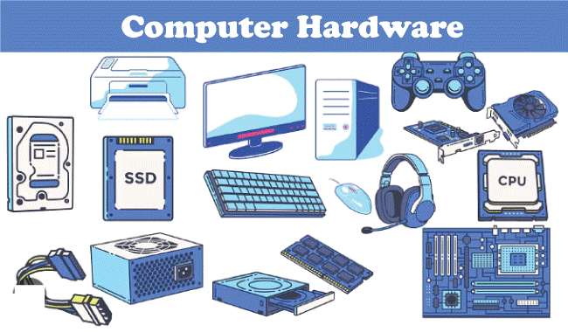

## **1.2. Types of Computer Hardware.**

Generally there are two types of computer hardware

* Internal hardware.
* External hardware.

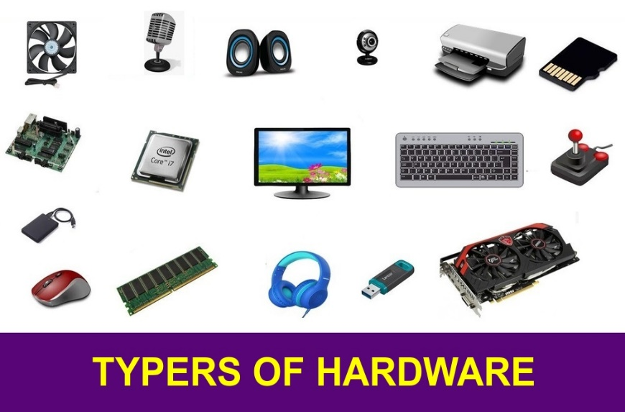

### **1.2.1. Internal hardware.**

Internal computer hardware refers to the components that are installed inside the computer cases or chassis. These components work together to enable the computer to perform various tasks. Here are some key internal hardware components:

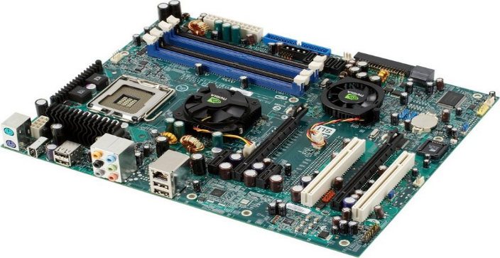

Figure 1: Motherboard

**1. Motherboard:**

This is a printed circuit board that holds the central processing unit(CPU) and other essential internal hardware and functions as the central hub that all other hardware components run through.

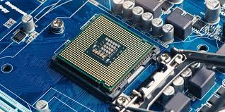**2. CPU:**

Figure 2: CPU

The CPU is the brain of the computer that processes and executes digital instructions from various programs, its clock speed determines the computer’s performance and efficiency in processing data.

**3. RAM:**

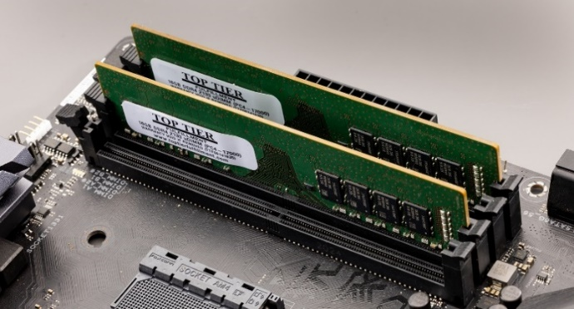RAM which stands for Random Access Memory is temporary memory storage that makes information immediately accessible to programs. RAM is volatile memory, so stored data is cleared when the computer powers off.

Figure 3: RAM

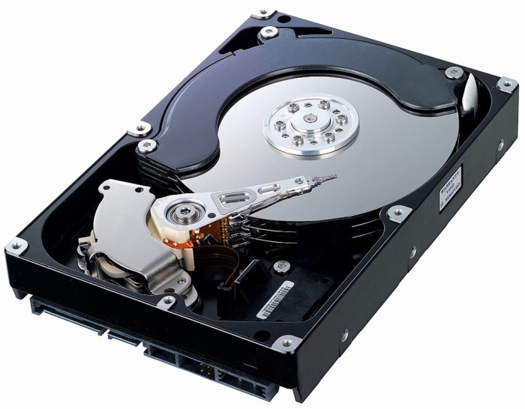

Figure 4: Hard drive

**4. Hard drive:**

Hard disk drives are physical storage devices that store both permanent and temporary data in different formats, including programs, OSes, device files, photos, etc.

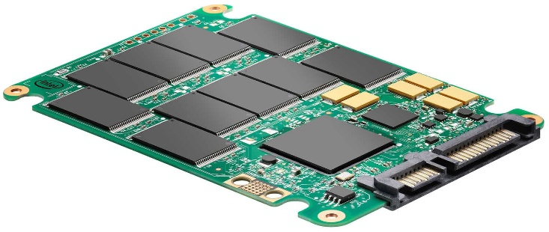**5. Solid- state drive(SSD):**

Figure 5: Solid- state drive

SSDs are solid-state storage devices based on NAND flash memory technology. SSDs are non-volatile, so they can safely store data even when the computer is powered down.

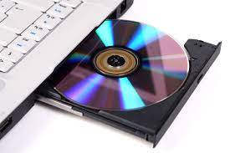 **6. Optical drive:**

Figure 6: Optical drive

Optical drives typically reside in an on-device drive bay, they enable the computer to read and interact with nonmagnetic external media, such as compact disc read-only memory or digital video discs.

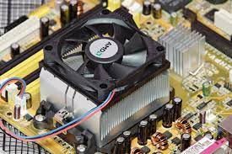**7. Heat sink:**

Figure 7: Heat sink

This is a passive piece of hardware that draws heat away from components to regulate/reduce their temperature to help ensure they continue to function property. Typically, a heat sink is installed directly atop the CPU, which produces the most heat among internal components.

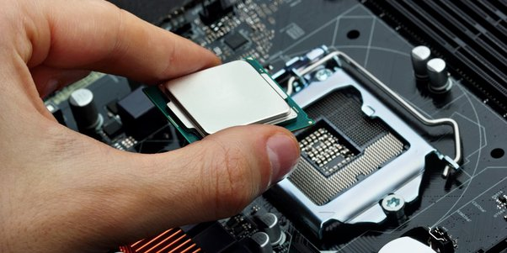

**8. Graphics processing unit:**

This chip-based device processes graphical data and often functions an extension to the main CPU.

Figure 8: Graphics processing unit

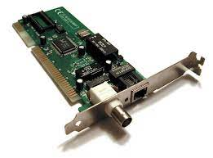**9. Network interface card (NIC):**

Figure 9: Network interface card

A NIC is a circuit board or chip that enables the computer to connect to a network, also known as a network adapter or local area network adapter, it typically supports connection to an Ethernet network.

### **1.2.2. External hardware.**

External hardware components, also called peripheral components, are those items that are often externally connected to the computer to control either input or output functions. These hardware devices are designed to either provide instructions to the software (input) or render results from its execution (output).

**Common input hardware components include the following:**

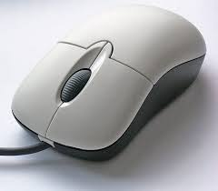 **1. Mouse:**

Figure 10: Mouse

A mouse is a hand-held pointing devices that moves a cursor around a computer screen and enables interaction with objects on the screen. It may be wired or wireless.

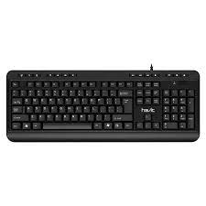

**2. Keyboard:**

A keyboard is an input device featuring a standard QWERTY keyset that enables users to input text, numbers or special characters.

Figure 11: Keyboard

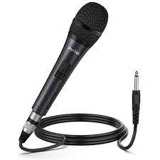

**3. Microphone:**

A microphone is a device that translates sound waves into electrical signals and supports computer-based audio communications.

Figure 12: Microphone

**4. Camera:**

A camera captures visual images and streams them to the computer or through a computer to a computer to a network devices.

Figure 13: Camera

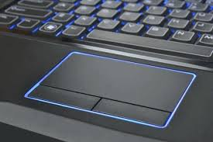**5. Touchpad:**

Figure 14: Touchpad

A touchpad is an input devices, external or built into a laptop, used to control the pointer on a display screen. It is typically an alternative to an external mouse.

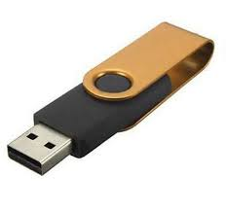**6. USB flash drive:**

Figure 15: USB flash drive

A USB flash drive is an external, removable storage device that uses flash memory and interfaces with a computer through a USB port.

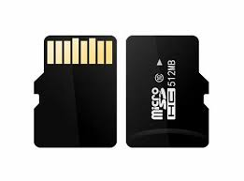

Figure 16: Memory card

**7. Memory card:**

A memory card is a type of portable external storage media, such as a CompactFlash card, used to store media or data files.

Other input hardware components include joysticks, styluses and scanner.

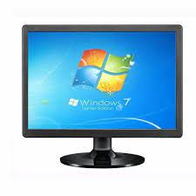**Examples of output hardware components include the following:**

Figure 17: Monitor

**1. Monitor:**

A monitor is an output device similar to a TV screen that display information, documents or images generated by the computing device.

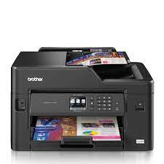 **2. Printer:**

Figure 18: Printer

Printers render electronic data from a computer into printed material.

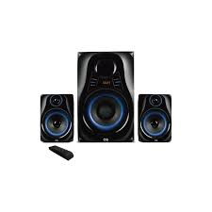**3. Speaker:**

Figure 19: Speaker

A speaker is an external audio output device that connects to a computer to generate a sound output.

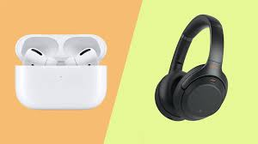**4. Headphones, earphones, ear buds:**

Similar to speakers, these devices provide audio output that’s audible only to a single listener.

Figure 20: Headphones, earphones, ear buds

## **1.3. How to building a computer.**

This intractable will cover the assembly of a personal computer. I will leave out what parts to pick because that is all dependent on the purpose for your specific computer. The computer I am assembling is one that I have been upgrading for the past two years. I needed to install it into a new case and decided to document the process to help others.

The order I used to assemble in can be changed depending on the circumstance of your build, i.e. case, CPU cooler, special components, dimension restrictions, newer technology.

This specific computer was designed around Folding @Home and gaming as well as just having a powerful system for new software and things to come.

### **1.3.1. Step 1: Remove Side Panels on Case.**

After removing the case from the box, the panels are removed from this case with thumb screws.  Your specific model's manual will have more information if you are unsure for your case. Included were standoffs for mounting the motherboard, following the included template, thread into the corresponding holes in the case.



Figure 21: Remove Side Panels on Case

### **1.3.2. Step 2: Insert Motherboard.**

In my assembly process, as I was just transferring the parts from one case to another, leaving the CPU cooler installed was the easiest option.  Depending on the motherboard, case, CPU and CPU fan, this might need to be done before installing or once in place.

Before setting the board in, the I/O panel faceplate needs to be snapped into the location in the back of the case.  Be sure to orient it to the board.

Once the board is resting in the case, line up the first hole, I suggest a corner.  Do not tighten all the way down until all screws are started so that the others will line up.

After all are in and tightened, there should be little or no deflection of the board if you gently press on it.  It is advisable that any place there is a mounting location for the board, that it is screwed into a standoff.  This will provide support while installing the components into the motherboard.

This case has a cutout for access to the back of the motherboard for the massive CPU coolers that have brackets that attach to the back of the board.

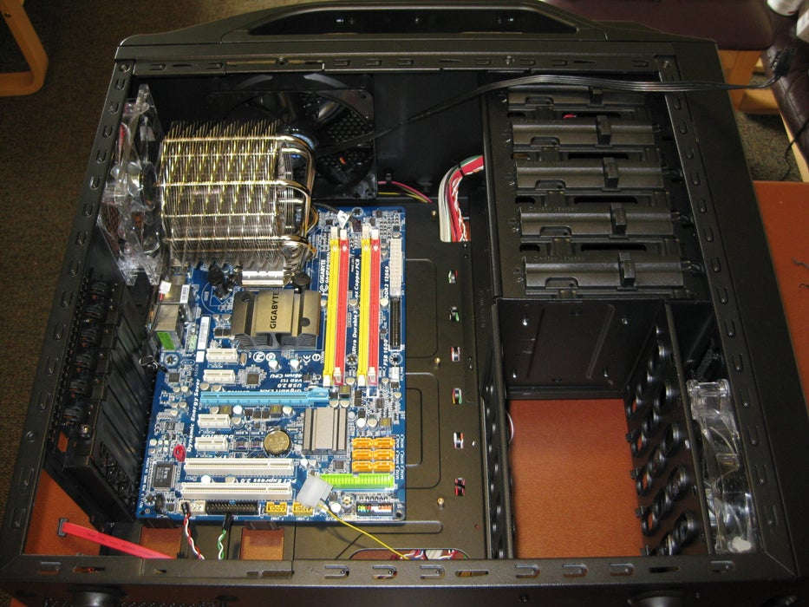

Figure 22: Insert Motherboard

### **1.3.3. Step 3: Check Clearances.**

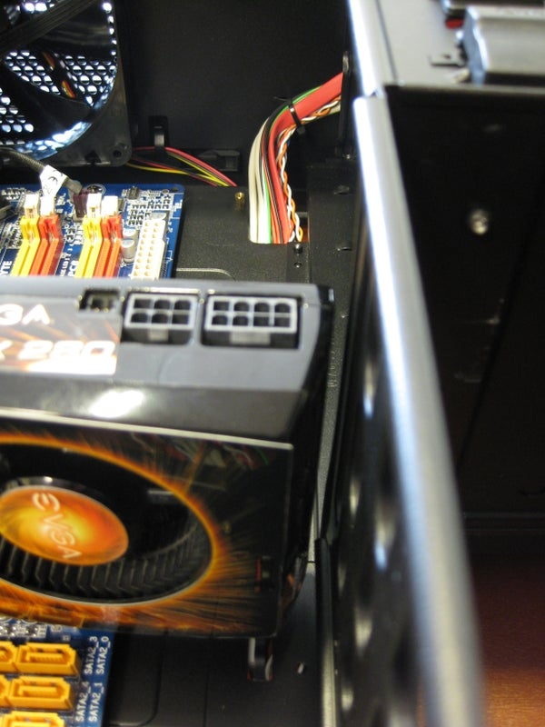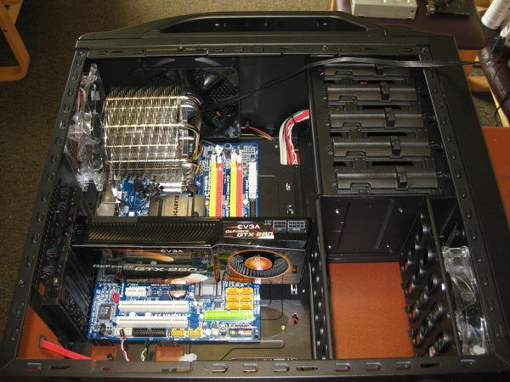Being that this computer includes high performance components, some of them are large enough that clearance can become an issue.  For this reason once the board was installed I fitted the graphics card so there would not be more surprises later in the process.

Figure 23: Check Clearances

### **1.3.4. Step 4: Front Panel Connections.**

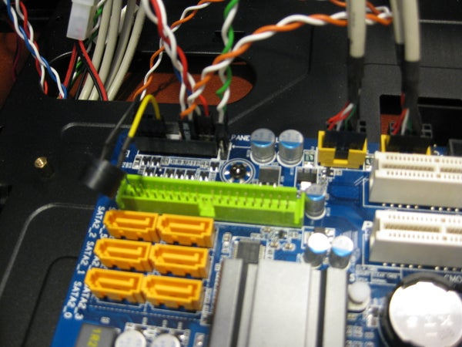Once the graphics card was removed again, it is time to attach the connections for the buttons, lights, USB ports and audio connections.  As every case and motherboard differ slightly, it is best to refer to the manual for the placement and orientation of connections.  Some of these connections are made to only work in one direction so be careful when using force, it might be in an incorrect orientation.

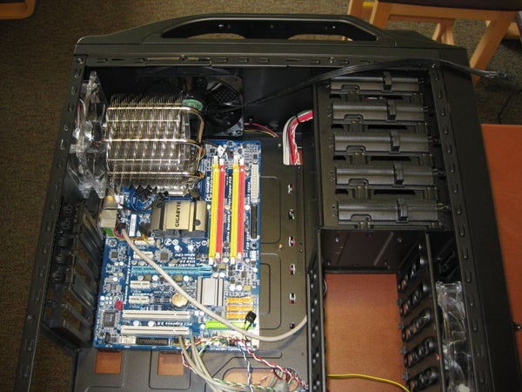

Figure 24: Front Panel Connections

### **1.3.5. Step 5: Install Power Supply.**

The power supply from the previous case was modular so only the cables that are needed are plugged into the unit.  As well this makes cable management cleaner in the end.  Normally the supply is screwed into the back panel by 4 screws, though some cases include a clamp to hold it down that way.

The second picture shows all of the cables that my computer needs to function properly.

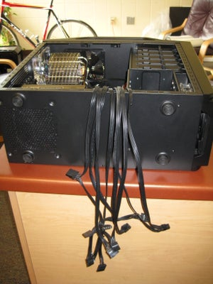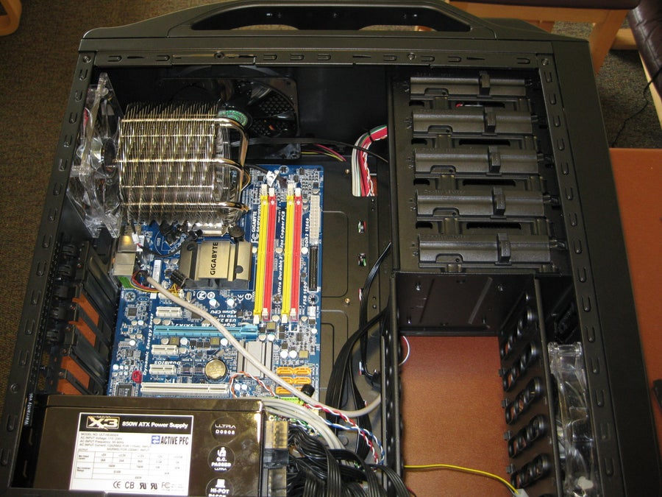Not pictured, below the supply there is a hole with filter for the power supply to circulate air independent of the case fans.

Figure 25: Install Power Supply

### **1.3.6. Step 6: Power Motherboard.**

With the motherboard power being the largest cable and sometimes just long enough, I suggest running this cable first and plugging it into the board, if there is a second cable for the CPU remember to connect it as well.

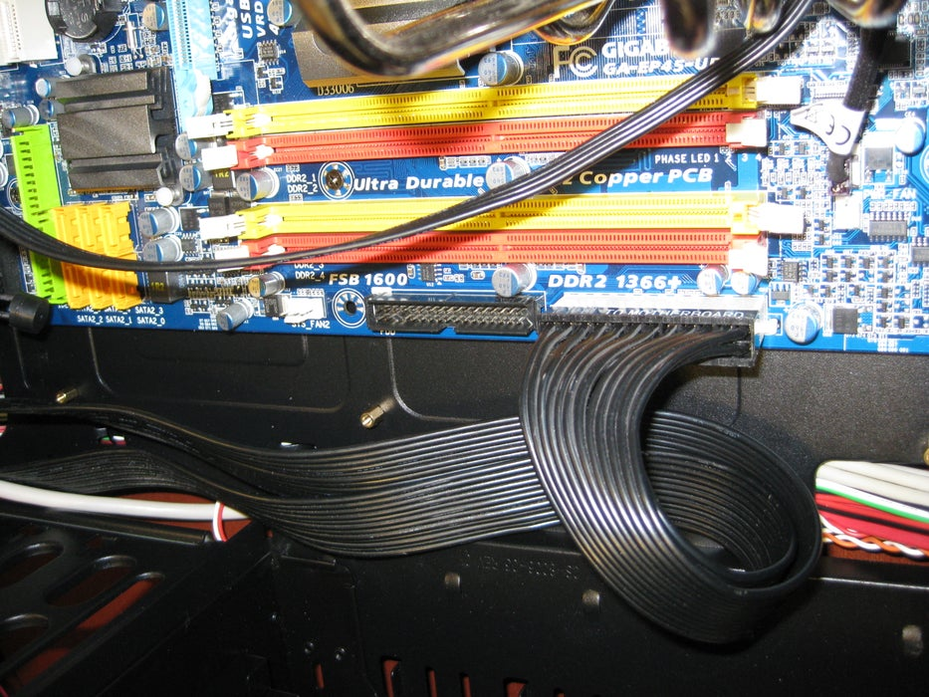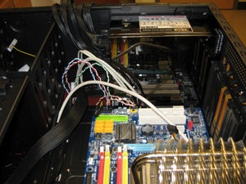

Figure 26: Power Motherboard

### **1.3.7. Step 7: Installing Optical Drive.**

The optical drive for this computer is a DVD/CD read/write combo.  Some people prefer to only connect an optical drive when installing items but one being in place at all times comes in handy when something comes up and you do not want to open the case and connect the drive.

The second picture shows the tool-less design of the case to hold the drive in place.

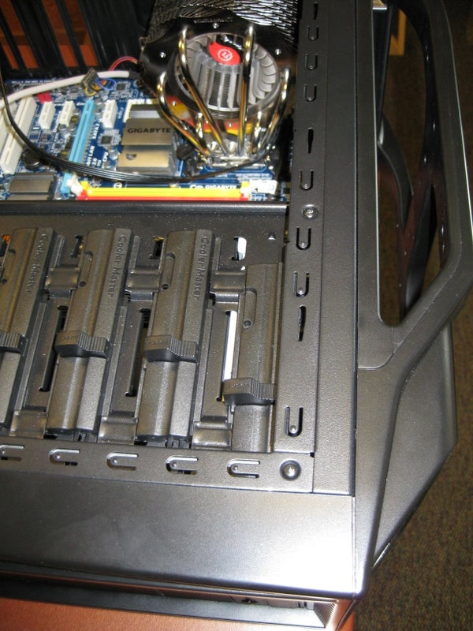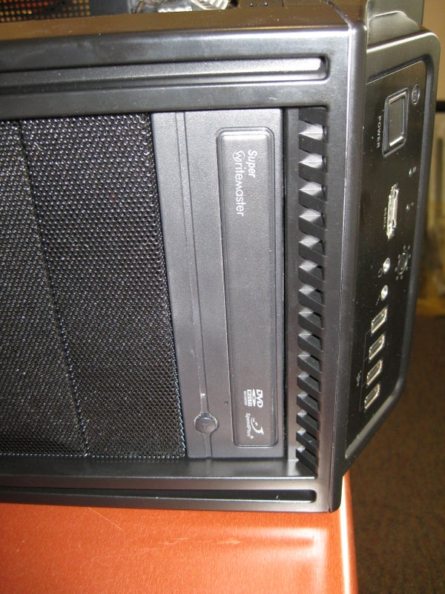

Figure 27: Installing Optical Drive

### **1.3.8. Step 8: Installing the Hard Drives.**

The size and number of hard drives your computer contains is completely dependent on your style of use and storage needs.  This computer uses 4 drives, two in raid and the rest for a main drive and miscellaneous storage.

Picture 2 shows the location for the drives in the case, this model has a cross mounted design, others might have them in the same direction as the optical drive installed previously.

Picture 3 is an example of possible tool-less drive mounting hardware, this clips allow the drive to be just slid in and lock into place.

Picture 4 depicts the drives installed and spaced out for air flow.  This is very important to extend the lifespan of the drive, key when you are making a long term investment or run your computer continuously.

Picture 5 shows the back of the drives where the connections for power and signal are made.

Picture 6 shows the cables attached.

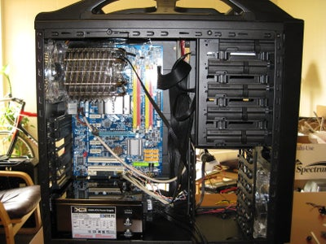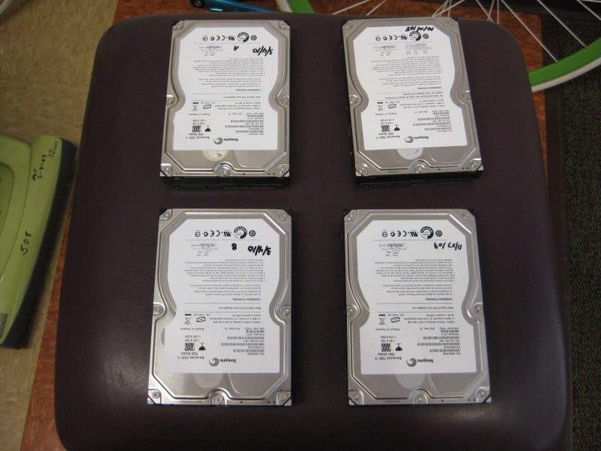

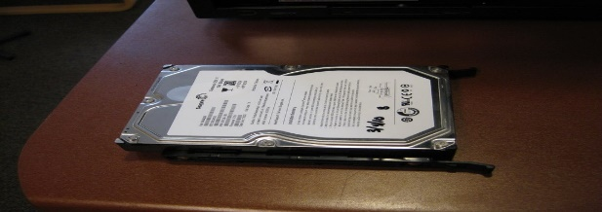

Figure 28: Installing the Hard Drives

### **1.3.9. Step 9: Connect Cables.**

It is time to connect the cables for the hard drives and optical drives.  The cables are keyed so they will only fit in one direction into the board, don't forget the cable that is attached to the optical drive.  This computer does not use the IDE cable but if you are connecting an older optical or hard drive they might require it.

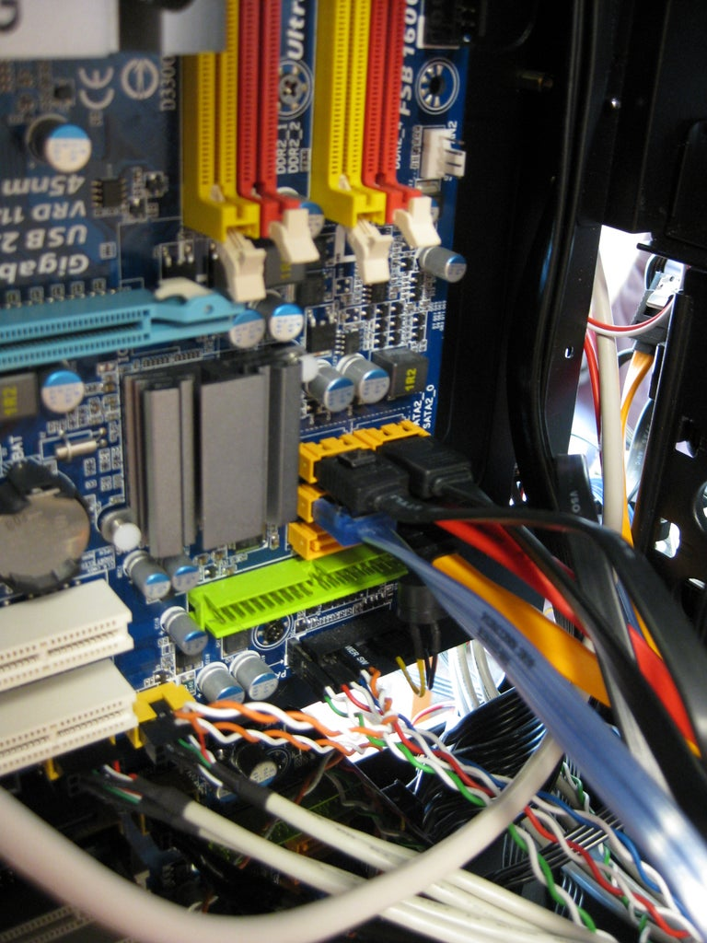

Figure 29: Connect Cables

### **1.3.10. Step 10: Install RAM.**

It is time for the ram to be inserted.  If your computer uses more than one stick like mine, refer to the manual for which slot to install the stick.  If only one stick is going to be inserted, place it in the slot closest to the CPU.

The slots are keyed as are the RAM sticks, so make sure the notch is lined up.  Even correctly lined up it will take considerable force, this is where having those standoffs in the correct spots pays off.  Having done this for several computers, I still get uneasy pushing so hard on electronics.

You will know when they are set firmly as the locking tabs will snap into place and hold the RAM firmly in the slot.

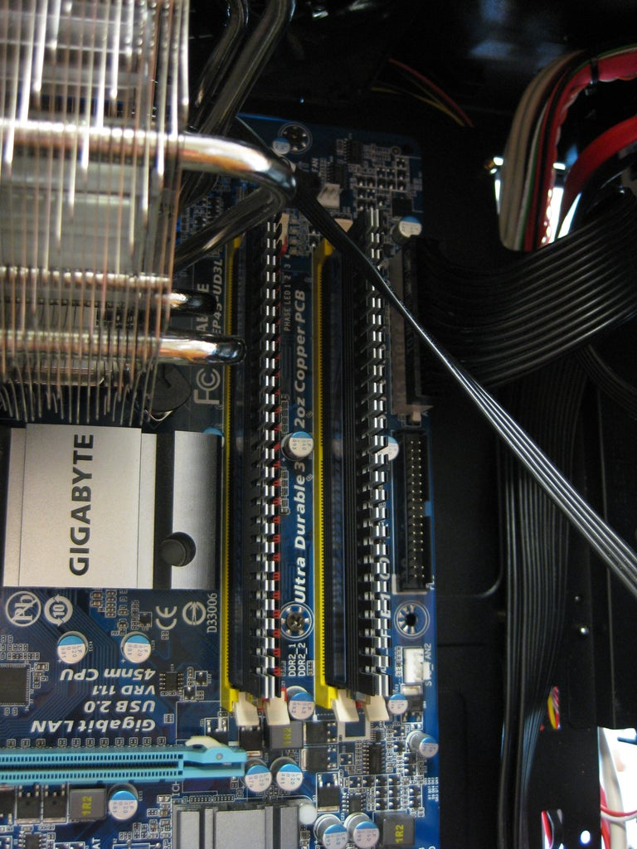

Figure 30: Install RAM

### **1.3.11. Step 11: Install Graphics Card and Expansion Cards.**

If your computer does not come with a graphics card integrated into the motherboard or you are adding an additional card, this is the time to do so.

With some high performance cards, additional power cables might need to be installed.  The manual for the card should tell you how many cables are needed.  In my case it is a 6-pin and an 8-pin.

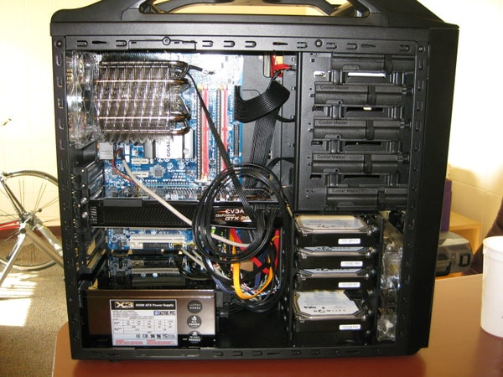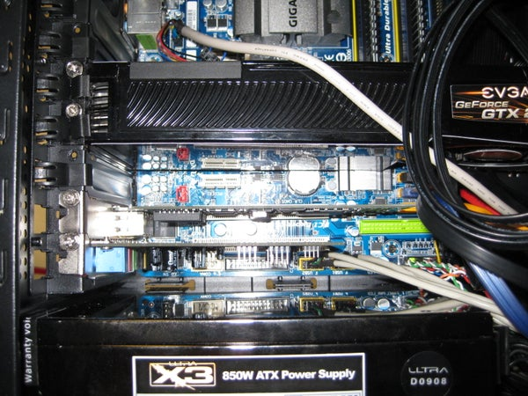After that is in place and secured with screws in place (a time where tool-less is not enough), the network card and audio card for the computer are connected into the slots below the graphics card.

Figure 31: Install Graphics Card and Expansion Cards

## 

### **1.3.12. Step 12: Cable Management.**

With all components in place, it is time to make your hard work look like a work of art.  Hiding cables and organizing them will help in the future if you are looking for high airflow through the case or to light it up. Small steps taken throughout the process of installing the components can pay of huge at this point by not needing to re-run the cables around brackets or through holes in the frame.  Some of the management was done out of the box for this model being that the front panel and fan cables were already secured ahead of time.  Another thing to think of is that the back panel does not leave a large space if you have several cables running over the top of others.

A few trial and error steps later this will look and perform with ease.  Also, it is a nice point to brag once you call up your friends to show off the system you assembled with your own hands.

This step is also when fans and lights can be connected.

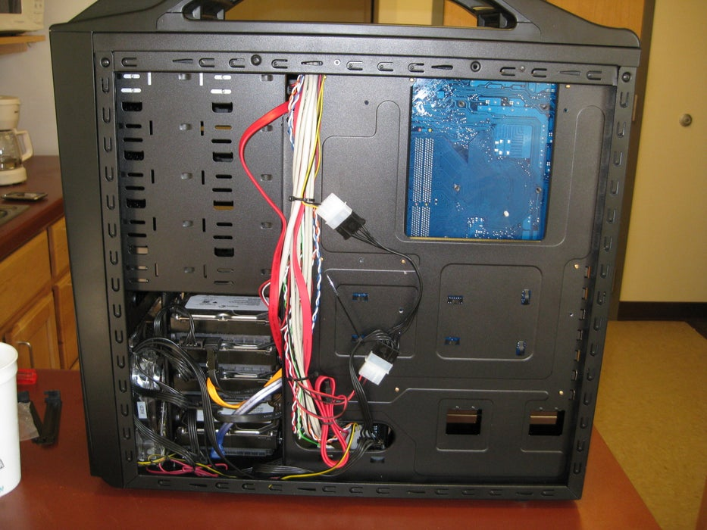

Figure 32: Cable Management

### **1.3.13. Step 13: Final Product.**

The assembly of a brand new computer can take several hours.  Just to remove and mount in a new case with no other modifications took me 3 hours, 2.5 of that just the re-installing time.

With the job complete it is time to fire it up and enjoy your creation.  From here you can add your operating system and software as you see fit.

Hope this helps you.  Leave a comment if there are questions you still have that were not covered.

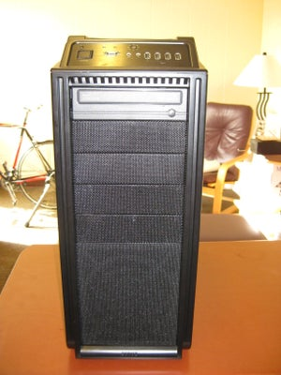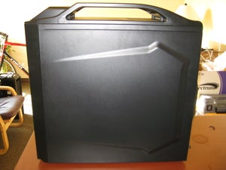

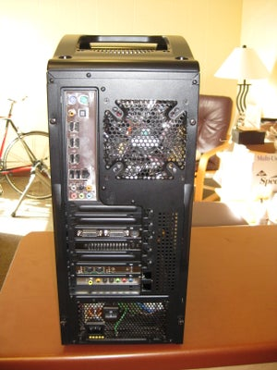

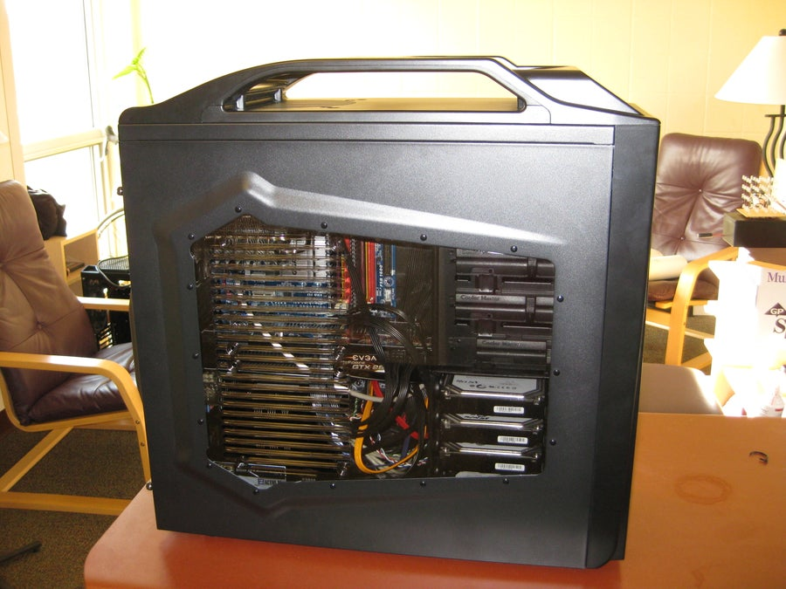

Figure 33: Final Product

# **2. Lab report of IIT on the topic of Computer virus and Antivirus.**

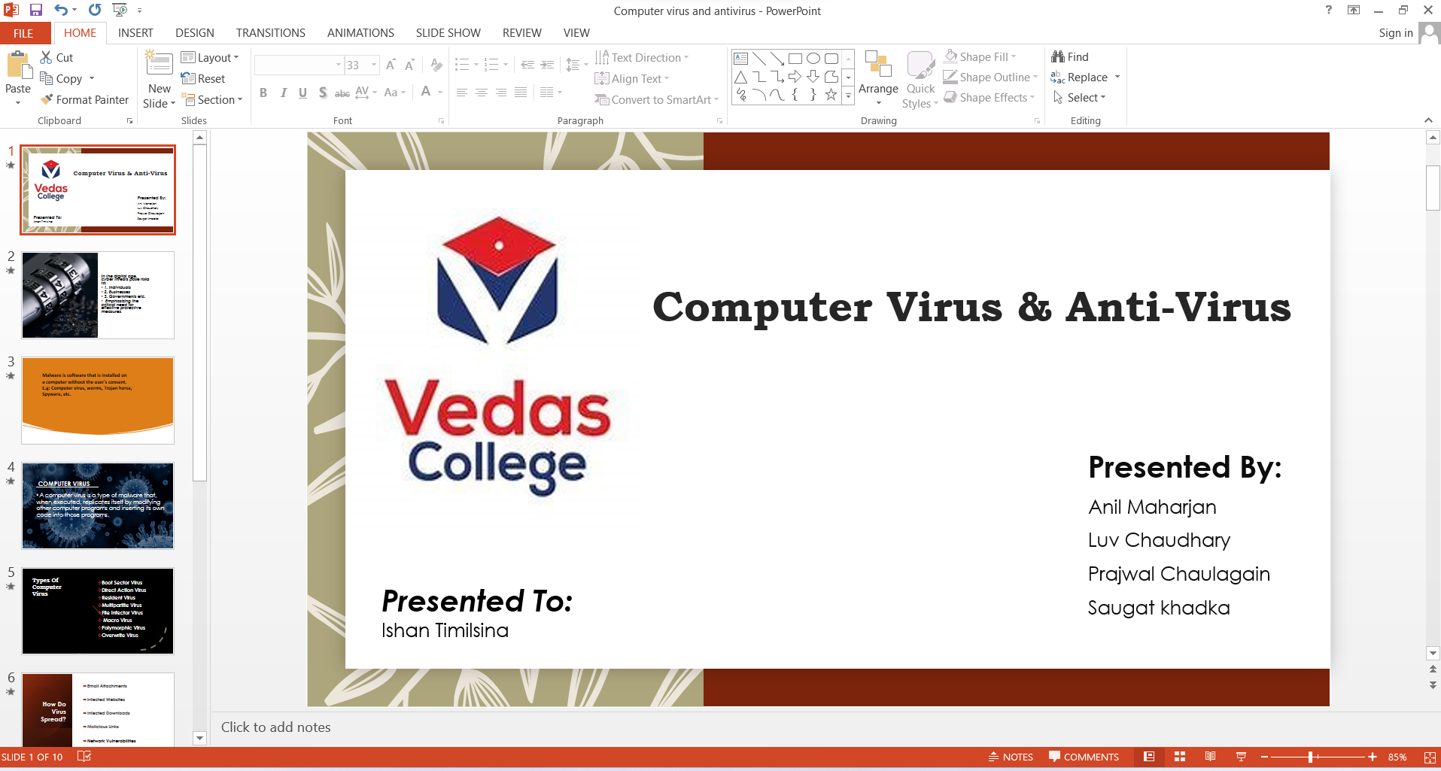

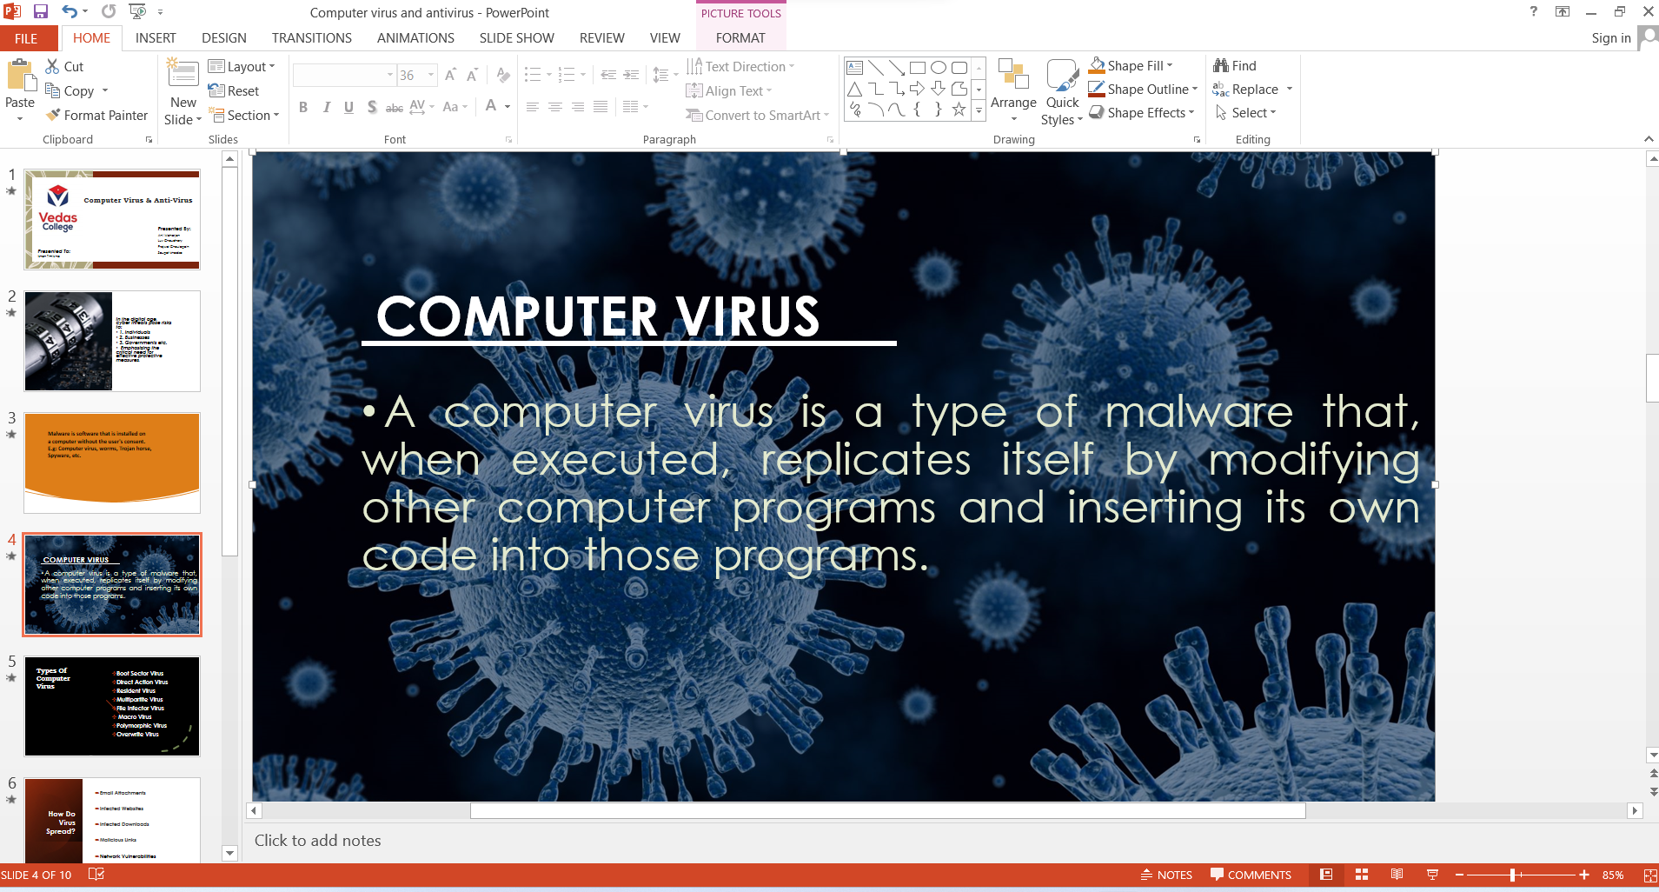

Microsoft PowerPoint is a widely used presentation program developed by Microsoft as part of the Microsoft Office suite. It allows users to create slideshows that incorporate text, graphics, multimedia elements, and animations. PowerPoint presentations are commonly used in business meetings, academic lectures, training sessions, and other situations where information needs to be communicated to an audience in a structured and visually appealing manner.

## **2.1. Opening Microsoft PowerPoint:**

Following Steps in opening Microsoft PowerPoint:

1. Click on the Start screen or search bar at the bottom was opened.

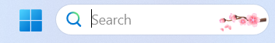

1. Then search “Microsoft PowerPoint” in the search bar.
2. When the Microsoft PowerPoint appeared as the search results, the “Microsoft PowerPoint” app was opened.

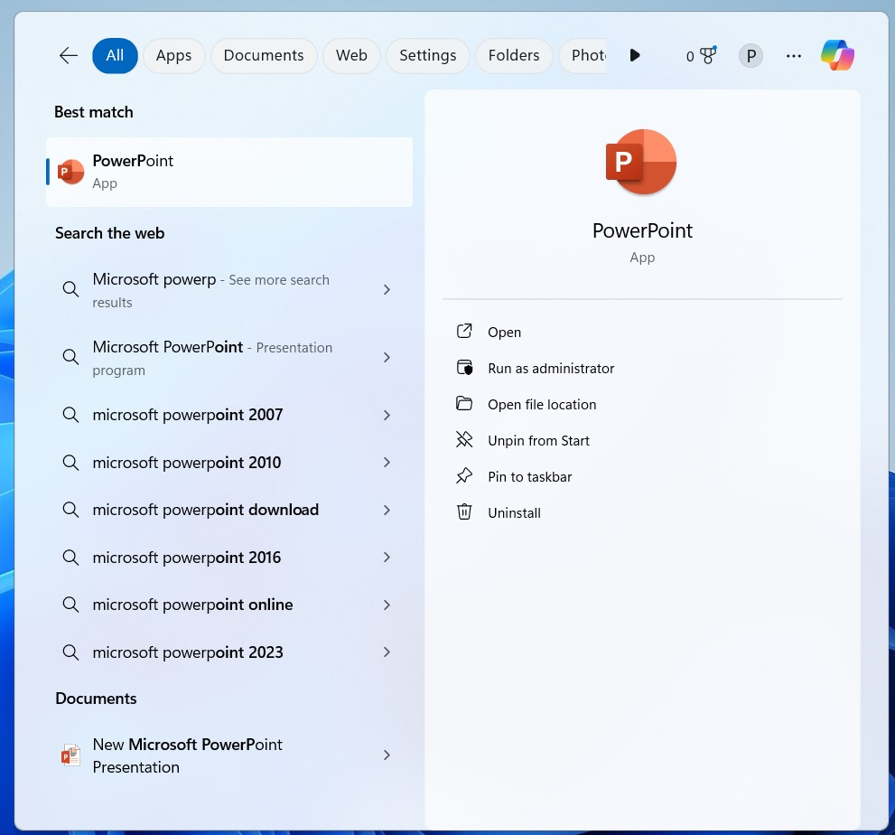

## **2.2. To Creating a new blank presentation:**

Creating a blank presentation in following steps:

* The Microsoft PowerPoint was open and click on the new file.
* Then the selecting new option, a blank presentation were selected to create a new presentation.

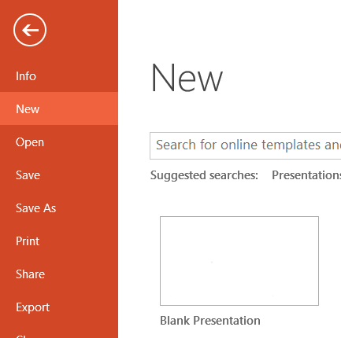

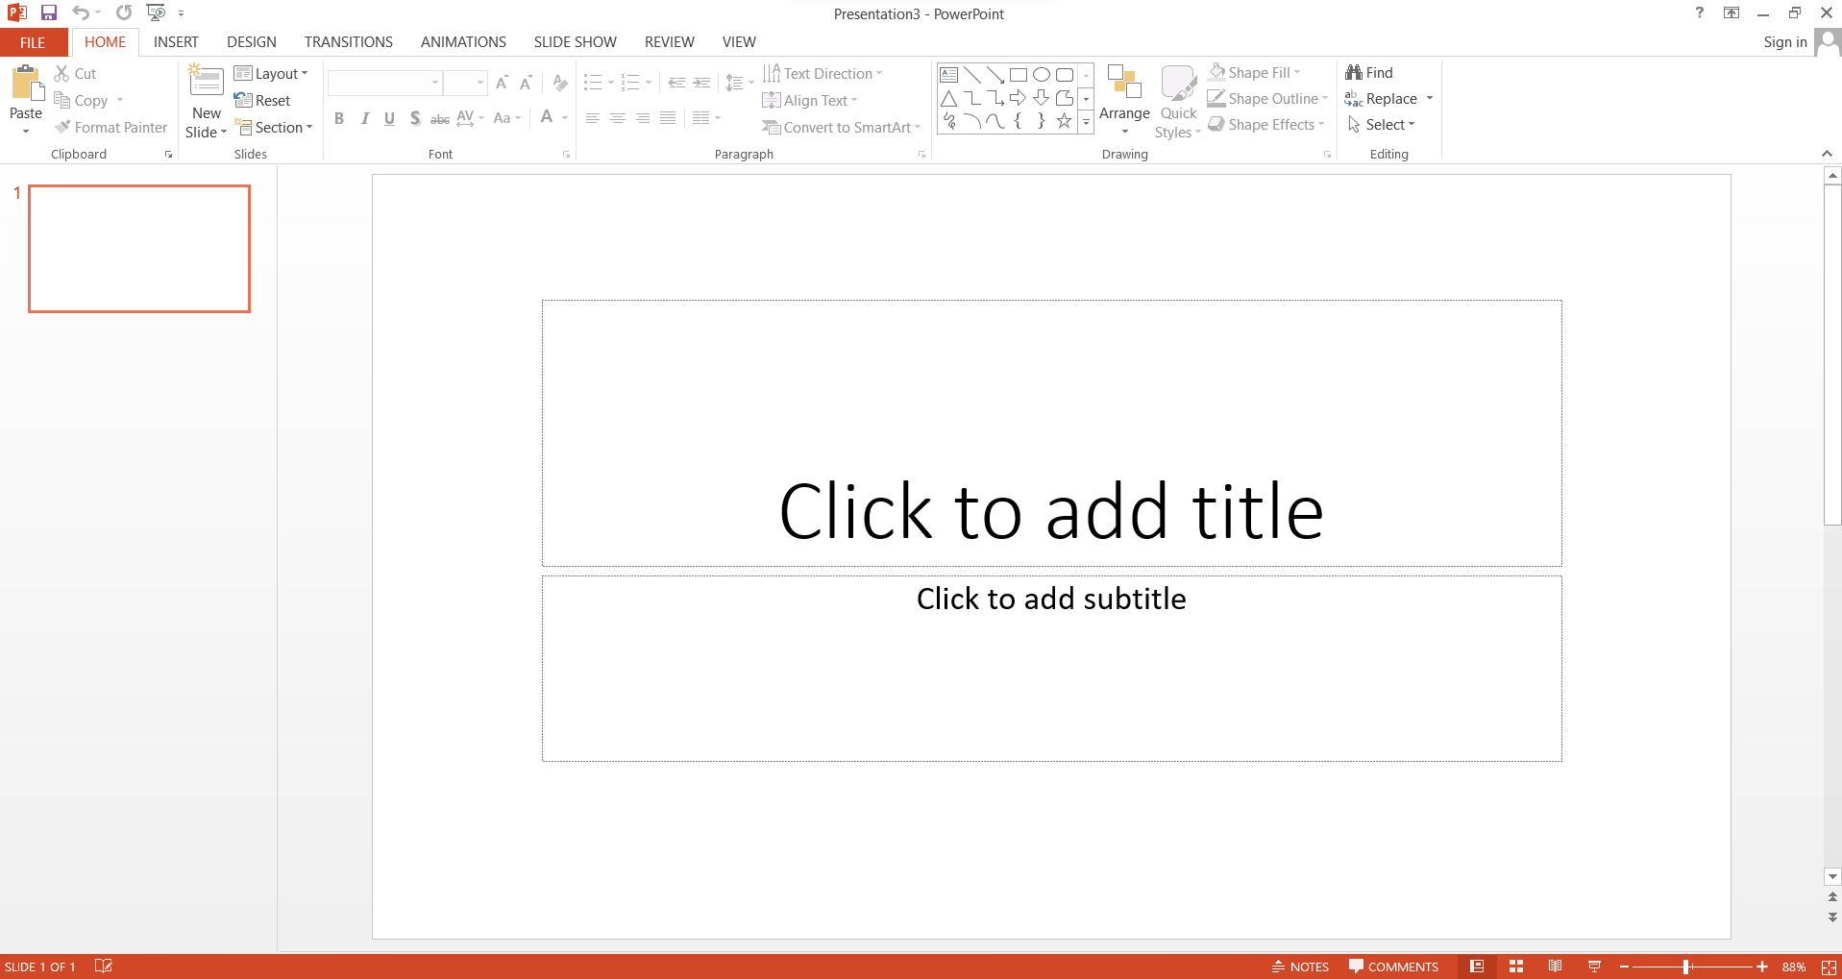

## **2.3. To create a new slide:**

To creating a new slide of following steps:

* Click on home in the top bar.
* After the selected “New Slide”.
* 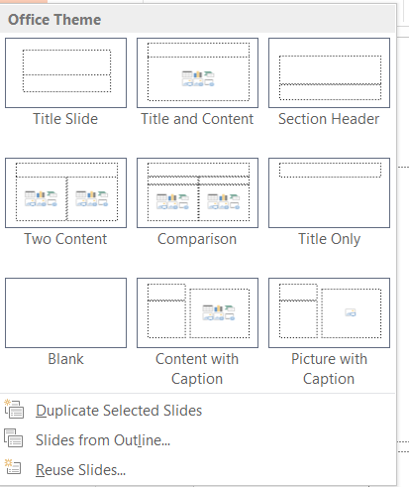To create a new slide.

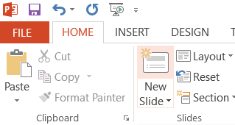

## **2.4. To change the font, font size and fond style:**

Changing the font size and fond style on the following steps:

* Open the Home tab.
* The font tab was used to change the font size and fond style.
* The size helps the user to increase the size of font.
* Set the font size to 50 and the fond style to “New Blod” for the article.
* The main heading, the font size was set to 40.
* Adjust the front pages, font size was set to 55.
* Choose the “Italic” option to make the text italic.
* To underline the text, “Underline” option was selected.

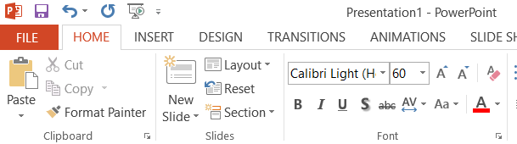

## **2.5. For the text align:**

The text align in the following steps:

* Open the Home tab.
* To under the “Home” tab, text align options given under paragraph section.
* To “Align left” for align the text to left.
* To “Align right” for align the text to right.
* To “Center” for align the text to the center.
* To “Justify” for evenly between the margins.
* The main heading was aligned to the center.
* The over of the titles and articles was aligned to the left.

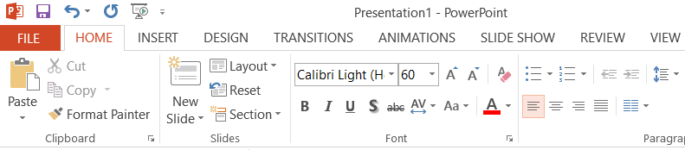

## **2.6. For insert images:**

The important image into the document in the following steps:

* Click on “Insert Bar” at the top.
* To select “Pictures” then “This devices”.
* 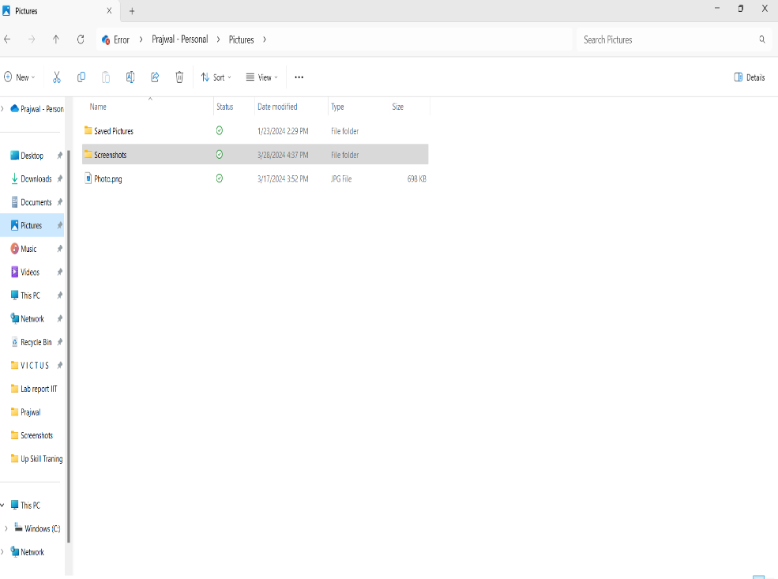Then desired folder was selected for important the image, after that image is selected and clicking the insert.

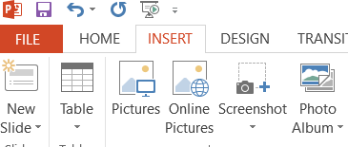

## **2.7. For design:**

The important design into the front page in the following steps:

* To click on “Design” on the top bar.
* To selected the desire Themes and variations.

## 2.8. For transitions:

The transition of the slide in the following steps:

* To select “Transitions” on the top bar.
* To choose the desired transition, you can add sound and duration in that particular part of Presentation.

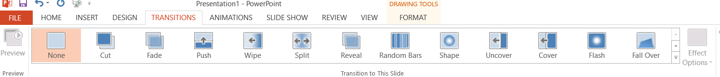

## **2.9. For the Animations:**

The implementing animations into the slides in the following steps:

* To select the “Animations” on the top bar.
* To select the desired animation for the presentation by selecting “Add Animation”.

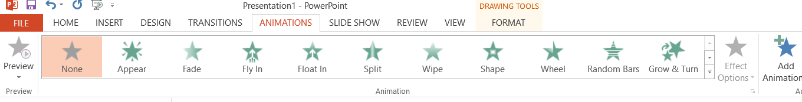

# **3. Lab report of IIT on Microsoft Word (MS Word):**

Microsoft Word is a word processing program developed by Microsoft, forming a part of the Microsoft Office suite. It is one of the most widely used word processing applications globally and is known for its extensive features, user-friendly interface, and compatibility with various file formats.

## **3.1. Opening Microsoft Word:**

To open the Microsoft Word in the following steps:

* At first, Click on the start screen or click on search bar at the bottom.



* Then, “Microsoft Word” was searching in the search bar.
* After searching the Microsoft Word appeared as the search results, the “Microsoft Word”.

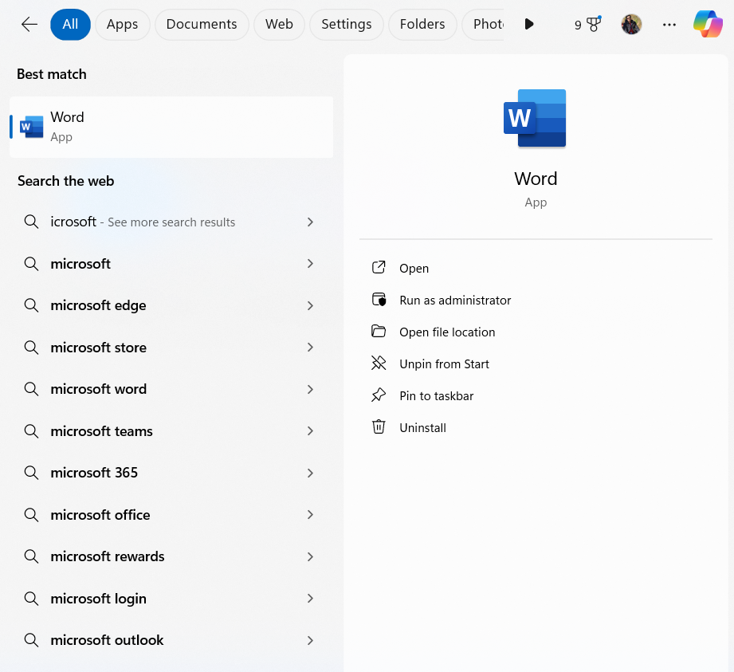

## **3.2. To create a new document:**

On the creating a blank document in the following steps:

* To click on open file and then click on new document.
* To selected create a document was selecting the “New’ option, blank document.

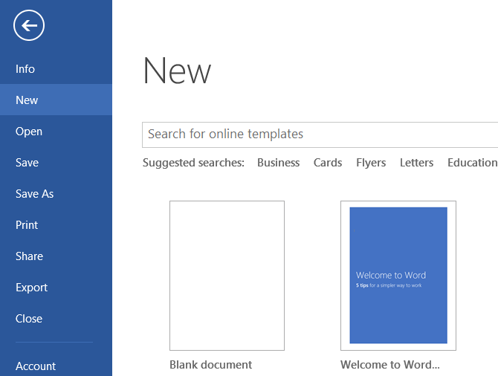

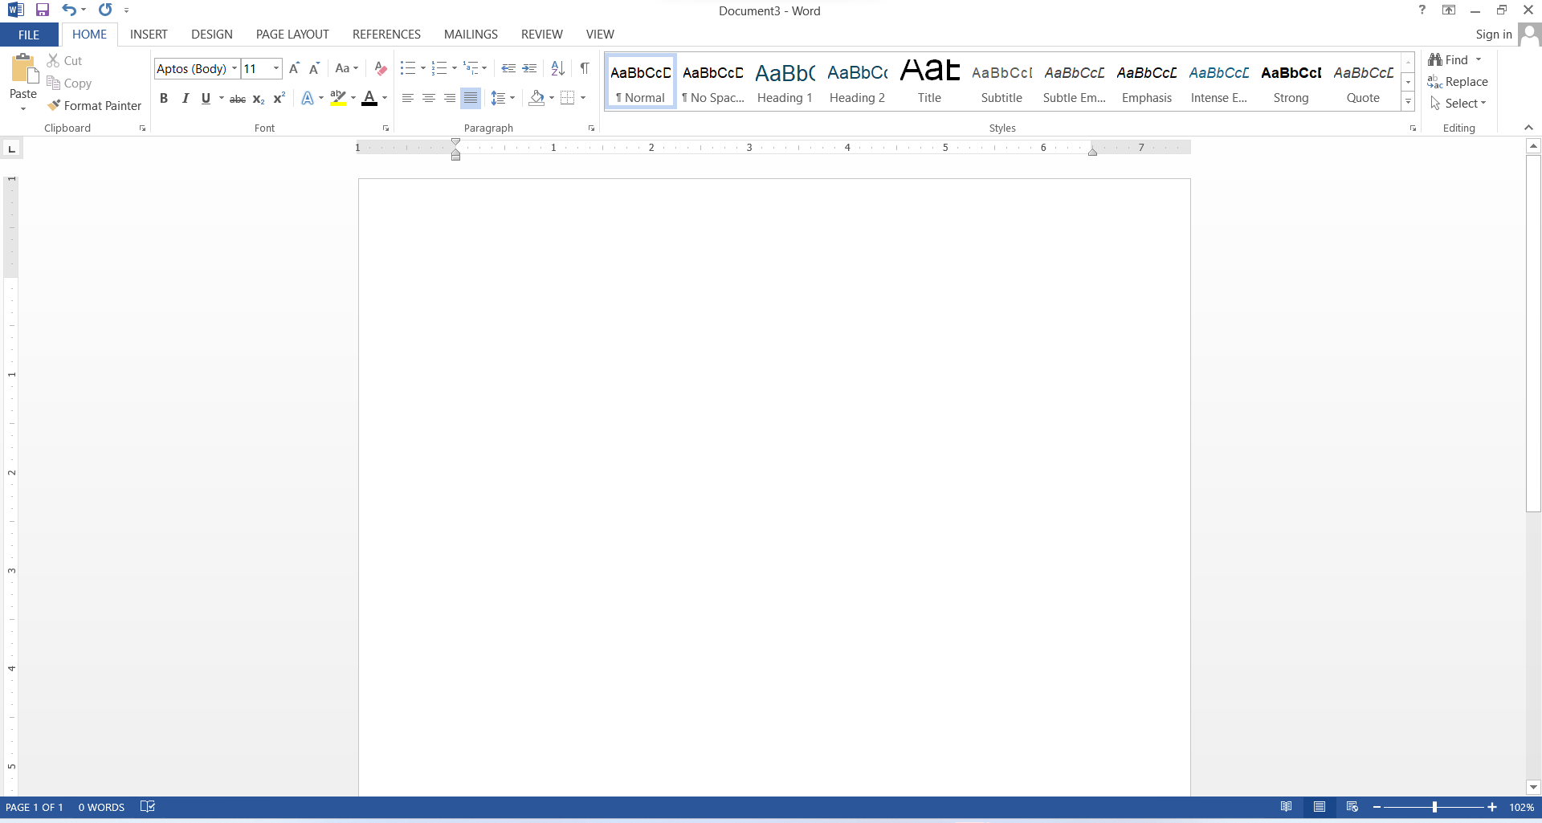

## **3.3. To change the font, font size and font style:**

The changing the font size and font style in the following steps:

* To opened the Home tab.
* To change the font size and font style used to font tab.
* To size helps the user to increase the size of font.
* To font color help the user to specify the color of select the text.

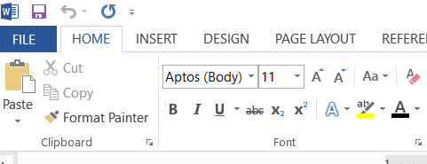

## **3.4. For the text align:**

To aligning the text in the following steps:

* To “Align left” for aligning the text to the left.
* To “Align right” for aligning the text to the right.
* To “Center” for aligning the text to the center.
* To “Justify” text evenly between the margins.
* To main heading was aligning to the center.
* To left over of the titles and articles was aligned to the left.

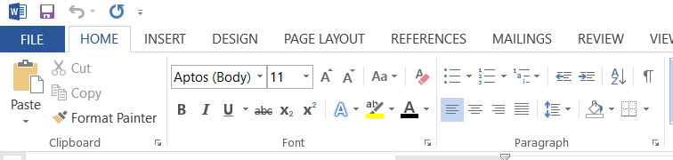

## **3.5. To select the style of the text:**

The styling of the text on the following steps:

* To open the “Home” tab.
* To click on “Design” on the top right bar nearly insert.
* To the heading, the styles were set to “TITLE”.
* 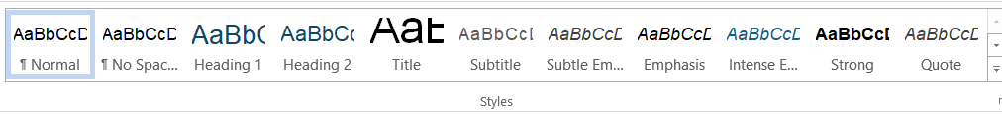To left over of the article, “NORMAL” styling was used.

## **3.6. To use “Drop Cap”:**

Using the “Drop Cap” on the following steps:

* To open the “Home” tab.
* To click the “Insert” tab, in the top right side, drop cap was selected.
* To appropriate option was chosen in the drop cap.
* To option “Dropped” was selected.
* To suitable font size and font was used.

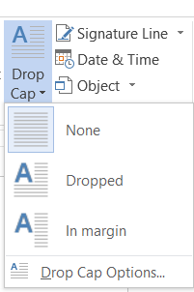

## **3.7. To insert image into the document:**

The inserting the image in the document on the following steps:

* To click on “Insert bar” at the top bar.
* To click on “Pictures” then “This Device” was selected.
* To desired folder was selected for important the image, after that image is selected and click on insert.

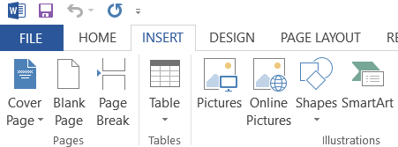

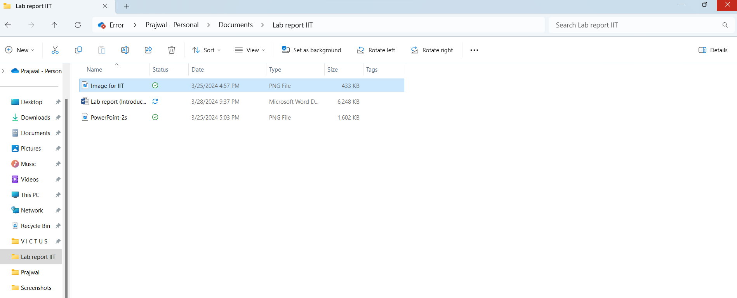

## **3.8. To insert shapes:**

**The inserting shapes into document on the following steps:**

* To open the “Insert” bar.
* To open the “Shapes”.
* To desired shape was selected and used for inside “Shapes”.

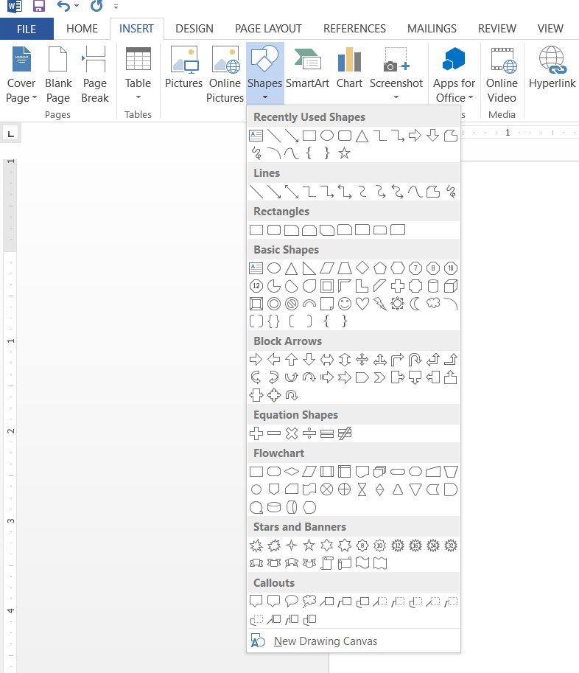

## **3.9. To use watermark in the document:**

Using watermark in the document on the following steps:

* To open the “Design” tab.
* On the top right section to inside “Design” tab for watermark was selected.
* On the option, either pre designed or custom watermark were applied to the document.

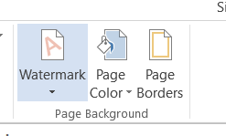

## **3.10. To set the margins:**

The setting up the margins in the document on the following steps:

* To open the “Layout” top bar.
* To the left side of the “Layout” bar, “Margins” was selected.
* To margins was selected according to the need.

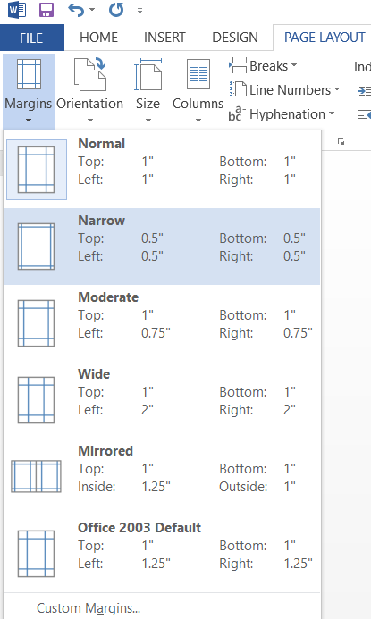

## **3.11. To Text Wrapping:**

The text wrapping in the following steps:

* To open the “Page Layout” top bar.
* To “Page Layout” bar, “Wrap text” was selected.
* To desired way of the text wrap was selected.

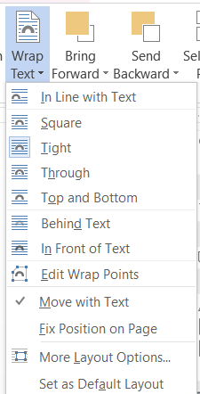

## **3.12. Source and reference:**

For the source and reference, following steps:

* To “Reference” is selected from the top bar.
* To “Insert Citation”, “Citation and Bibliography” was selected.

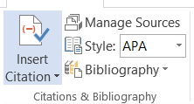

* To selected is the style of the Bibliography from the “Style” selection. For our bibliography, “APA” style was selected.

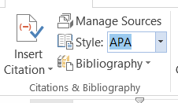

* To “Add New Source” was selected, To adding a new source.



### **3.12.1. To create a new source:**

**Creating a new source on the following steps:**

* **To selected was “Add New Source”.**
* **To selected then suitable type of source.**
* **To filled as respect to form is information.**

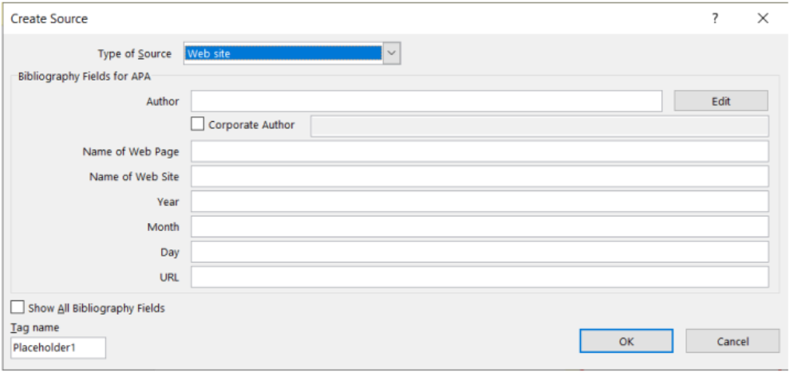

### **3.12.2. To saving the file.**

To saving the file on the following steps:

* To “FILE” bar was selected on the left corner.
* To selected was “Save” option.
* To selected then, “This PC”.
* To the file was saved then, the name and the location of the document was selected.
* To under the of “Lad report IIT” as the file was then saved to “Documents”.

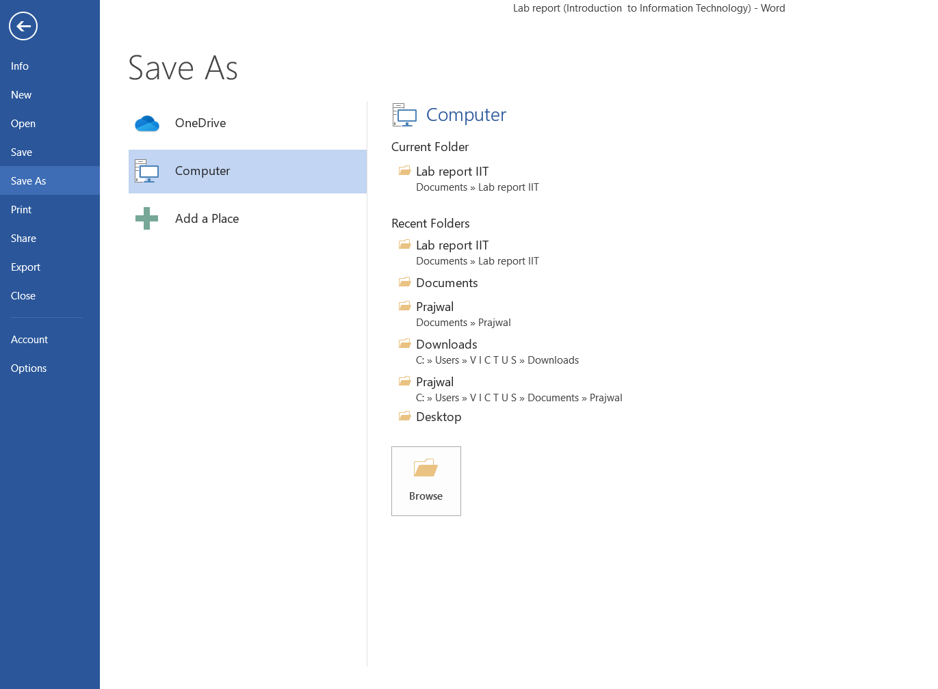

# **4. Lab report of IIT on the topic of Microsoft Excel (MS Excel).**

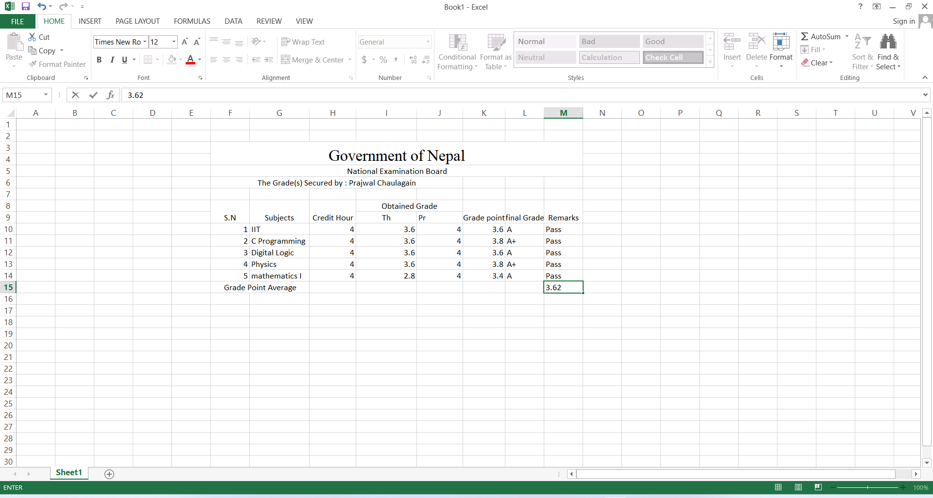

## **4.1. Opening Microsoft Excel:**

To Opening Microsoft Excel on the following steps:

* To click on the search bar at the bottom or click on the Start Screen.



* To search “Microsoft Excel” in the search bar.
* To open the app “Microsoft Excel”, when the “Microsoft Excel” was appeared as the search result.

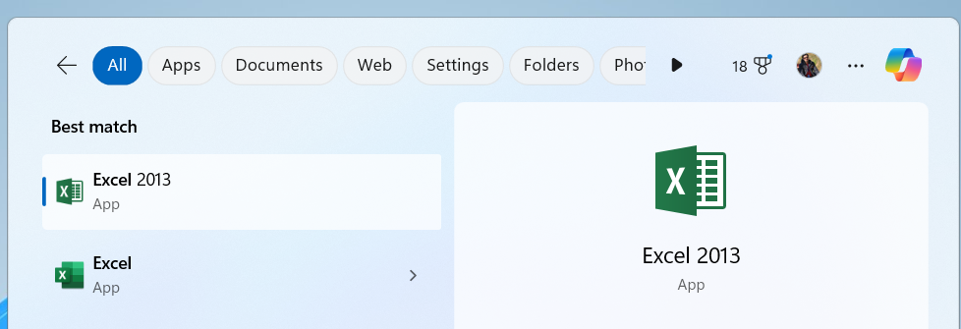

## **4.2. To create a new blank sheet.**

To creating a blank sheet on the following steps:

* To opening the “Microsoft Excel”.
* To opened “New” option on the left side of the display.
* To open a document, searching the “New” option, blank document was selected.

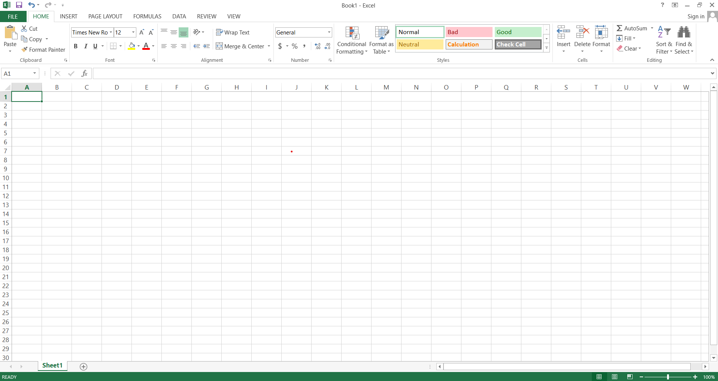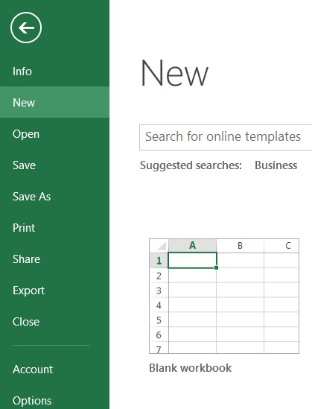

## **4.3. To change the font, font size and font style.**

To changing the font, font size and font style in the Microsoft Excel on the following steps:

* To opened the “Home Tab”.
* To font helps the user to pick a new font for the text.
* To size helps the user to increase the size of font.
* Font color help the user to specify the color of selected text.
* To “Bold” option to used to font bold.
* To “Italic” option was used to font italic.
* 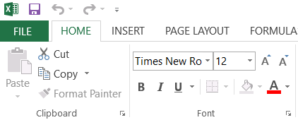To “Underline” option was used to underline the texts.

## **4.4. To aligning the texts:**

To aligning the texts on the following steps:

* “Top Align” option was chosen to align the texts to the top.
* “Middle Align” option was chosen to align the texts on middle.
* “Bottom Align” option was chosen to align the texts on the bottom.
* “Justify” texts for distributing evenly between the margins.
* The main heading was aligned to the center.
* The over of the titles and articles were aligned to the left and bottom.
* 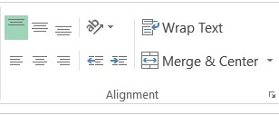

## **4.5. To merge the texts:**

To merging the texts on the following steps:

* To opened was “Home” tab.
* To under “Alignment” selection “Merge and Center” option was chosen.

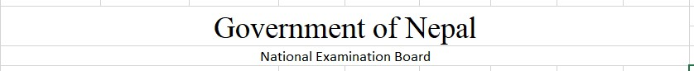

## **4.6. To wrap the Texts:**

To wrapping the texts on the following steps:

* **To open was “Home” tab.**
* 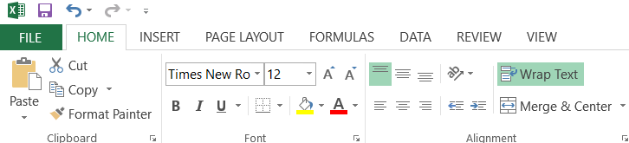**To under “Alignment” section, “Wrap text” was selected to wrap text.**

## **4.7. To set the border:**

To setting of the border on the following steps:

* To opened was “Home” tab.
* To under “Font”, “Borders” option was opened.
* 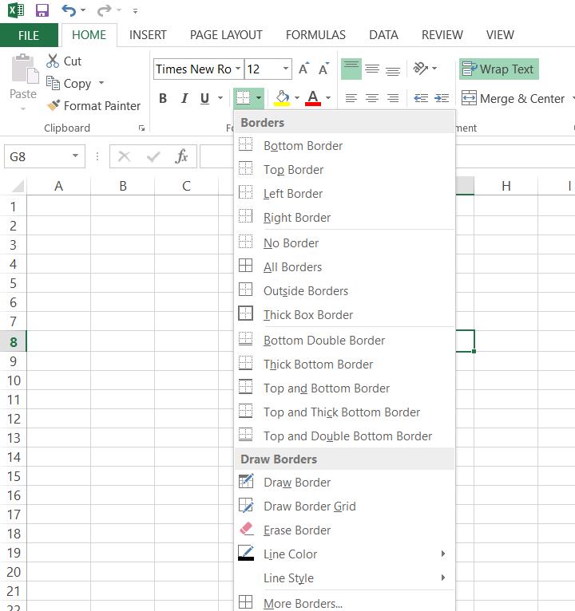To the table, “All Borders” option was selected.

## **4.8. To change the orientation of the text:**

To changing the orientation of the text on the following steps:

* To open the “Home” tab.
* To selected “Orientation” in the alignment section.
* To choose the text according to your needs.

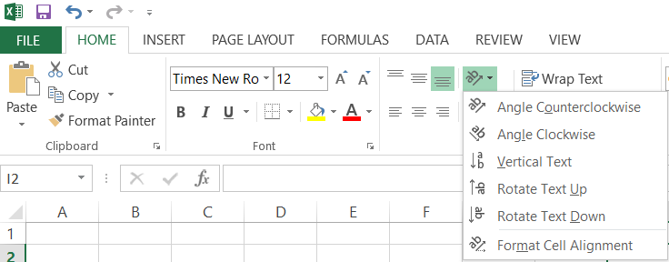

## **4.9. To set margin:**

To set margin in the document on the following steps:

* To opened the “Page Layout”.
* To select on the left side of the “Layout” bar, under “Page Setup” select, “Margin”.
* 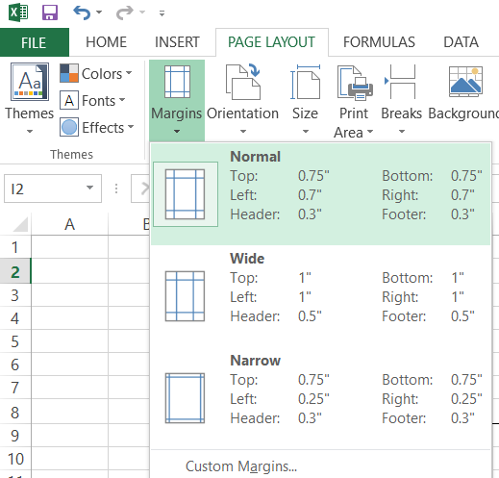The margin was selected according to the need.

## **4.10. For formulas:**

### **4.10.1. For total marks:**

* To select on total mark cell then select on “Formulas” section.
* To click on “Auto sum” select the sum the select every cell you want to add.
* After selecting each cell don’t forgot to add s(+) in between them.

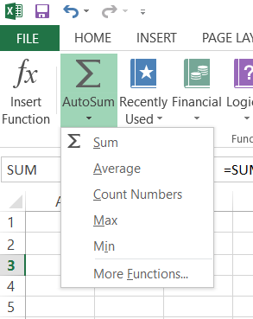

## **4.11. For saving the file:**

To saving the file on the following steps:

* To “FILE” bar was selected on the top left corner.
* To “Save” option was selected.
* Then, “This PC” was selected.
* Then, the name and the location of the document was selected and the file was saved.
* The file was then saved to “Documents” under the name of Lab report IIT.

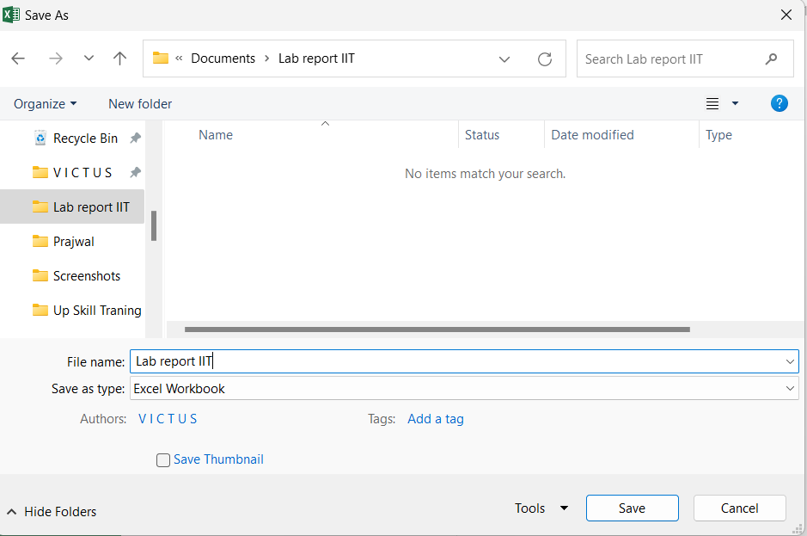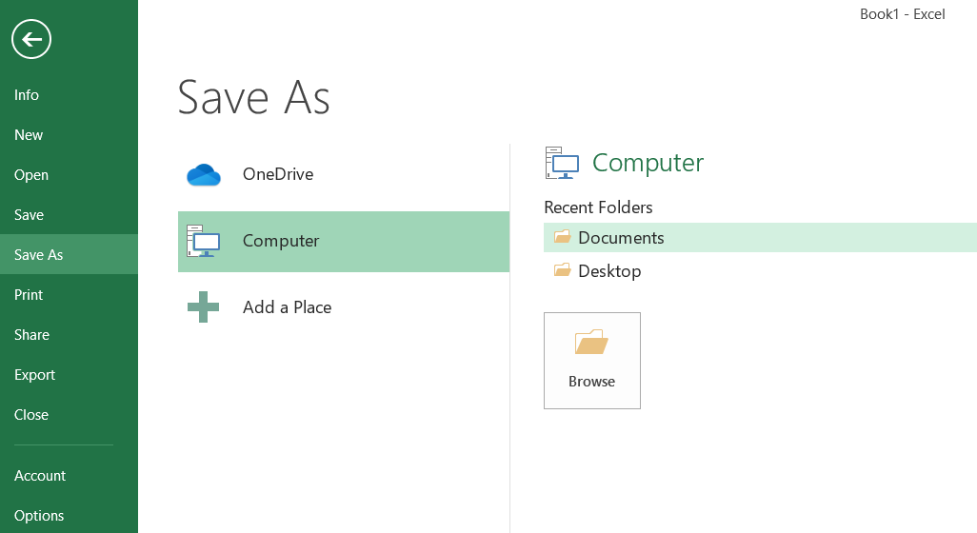

# **5. Lab report of IIT on the topics of Microsoft Dos.**

Microsoft DOS, or MS-DOS, was a command-line based operating system for IBM-compatible personal computers. It dominated the PC market during the 1980s and early 1990s. MS-DOS provided a text-based interface for managing files and running programs. It was eventually replaced by Microsoft Windows, starting with Windows 3.0 in 1990.

## **5.1 To Opening Microsoft Dos.**

Microsoft Dos can be opened on the used of command prompt icon or it can be opened directly into a certain folder.

To open the Microsoft Dos window into a certain folder as steps:

* To be opened, Go to the folder into which the command prompt.
* To click on address bar then type “cmd”.
* It will open this type of windows.

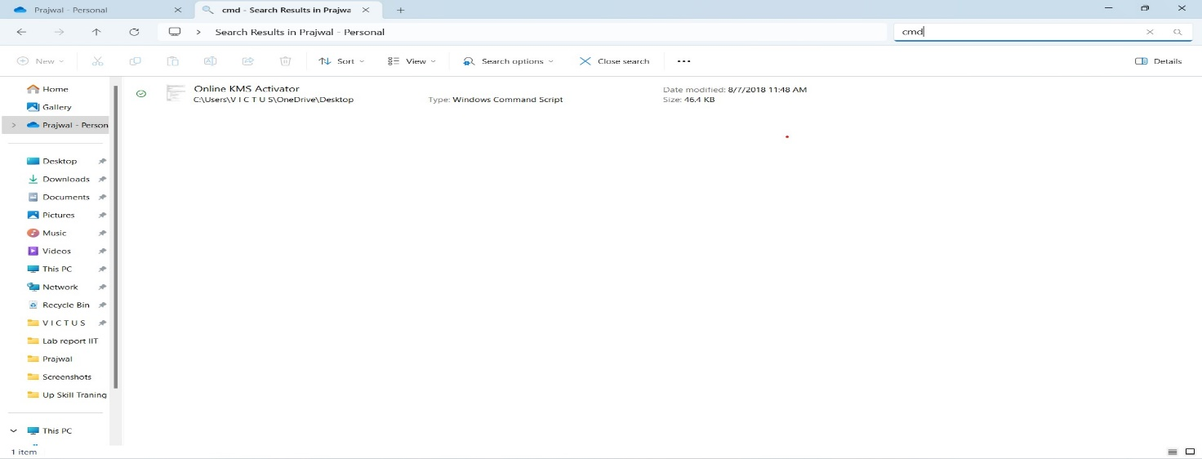

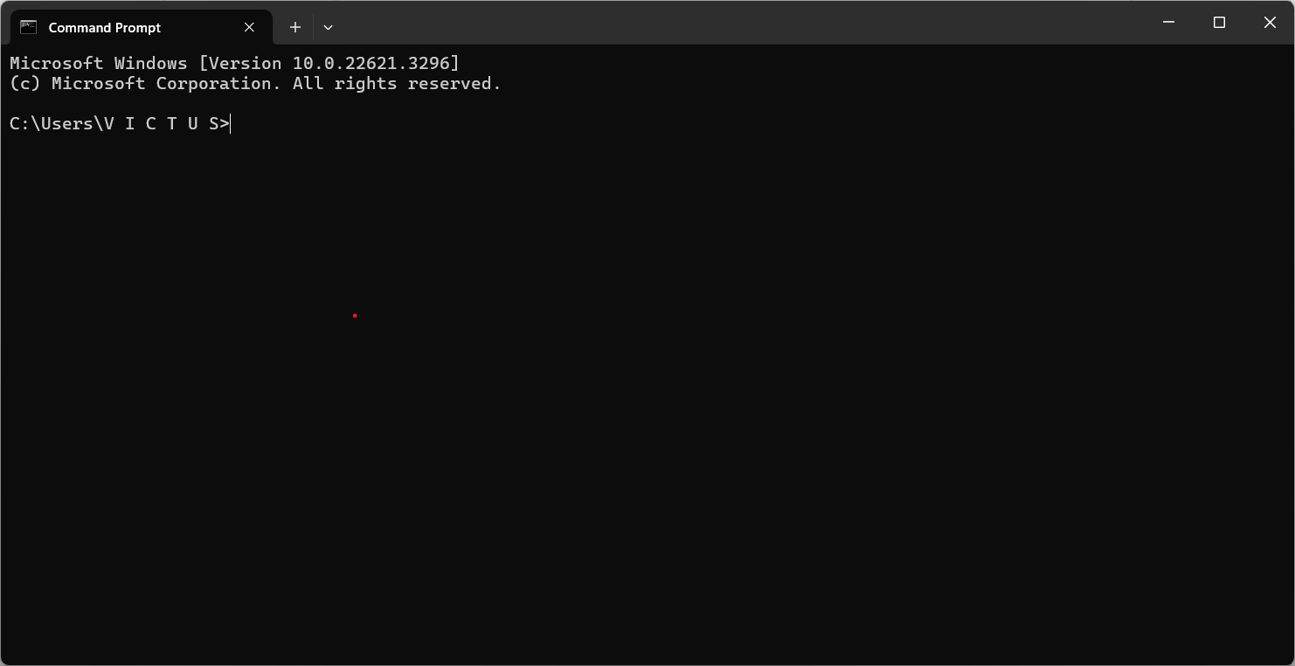

* You can easily open command prompt by clicking in search bar and type “cmd”.



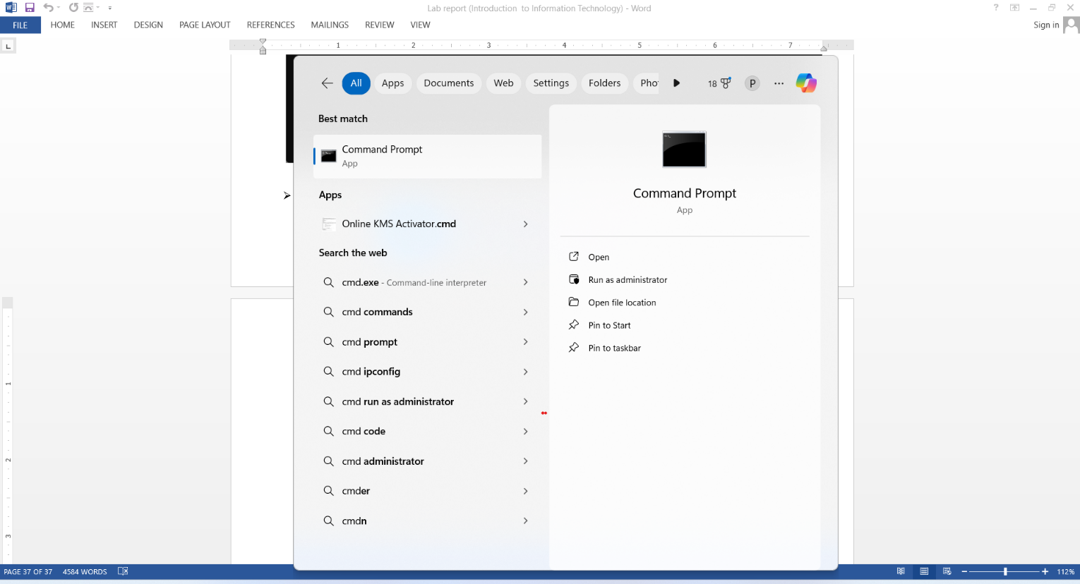

## **5.2 To change the color of the command prompt:**

* Then press enter after opening cmd in file type “COLOR [attr]”.
* 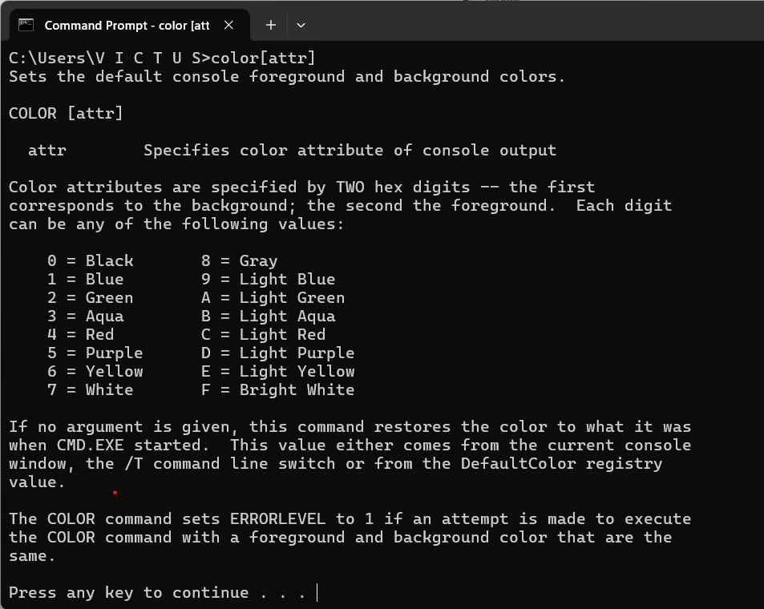Then you will see s window like below pop up.

* When you enter “COLOR fc” will you see the popped windows will turned into something like this in the given below.

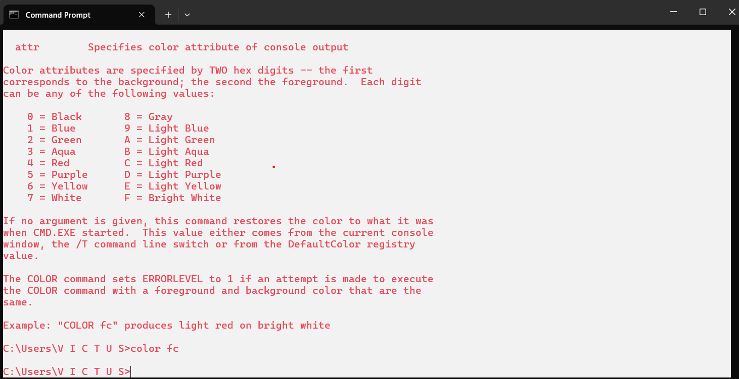

## **5.3 To show TIME and DATE:**

You can change the time and date by this steps:

* To opened the “cmd”.
* To write “date” then press entered.

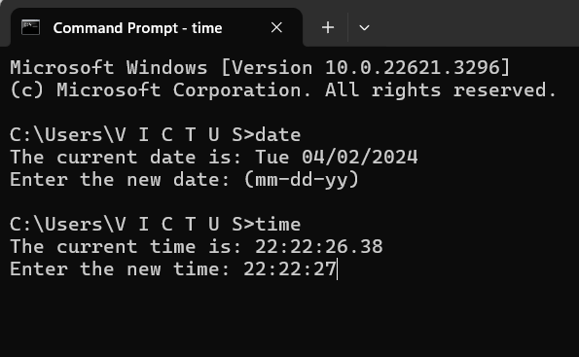

## **5.4 To change directory:**

* At first, run the “cmd” as the administrator.
* Then type “cd” don’t press the enter yet.
* After that copy the folder path.
* To like below then paste it after “cd”.

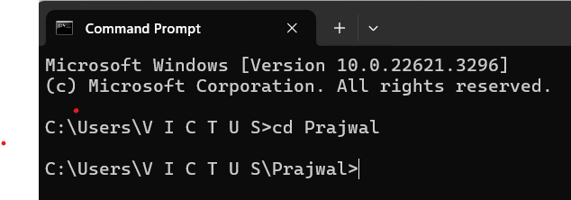

## **5.5 To Show Directory Tree:**

* To open “cmd” then write “tree”.
* To press the enter.

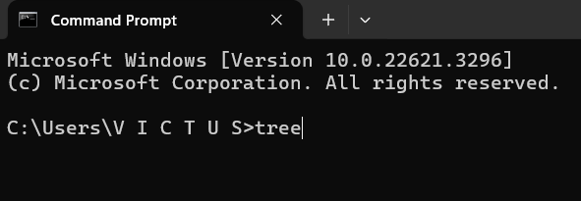

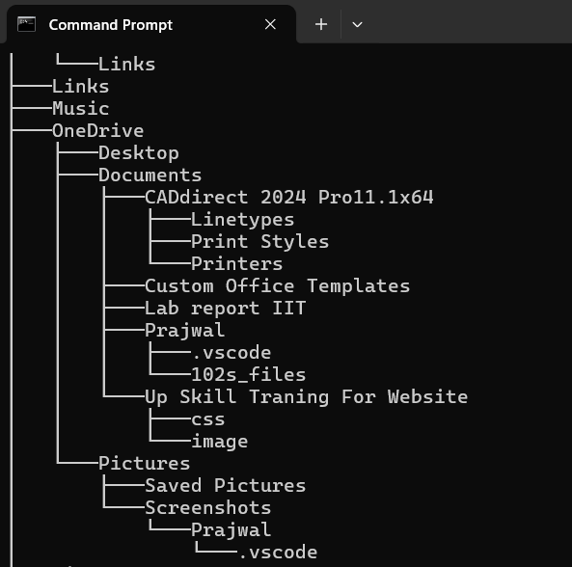

ss

## **5.6 To change title of the command prompt:**

* To changing the name of “Command prompt” open “cmd”.
* Then type “Title and make space and write a name as you like is choose “Prajwal” then press enter.

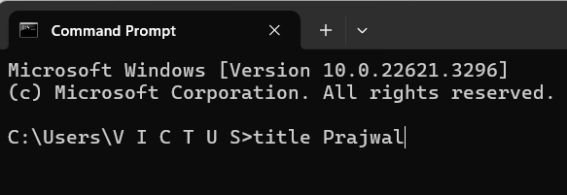

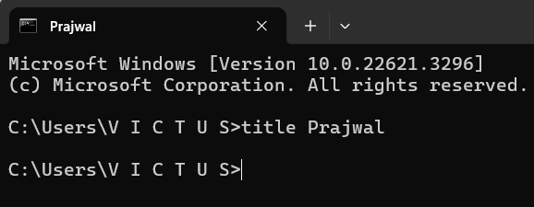

## **5.7 To clear command prompt:**

* To clear the screen of the command prompt simply write “cls” then press enter.

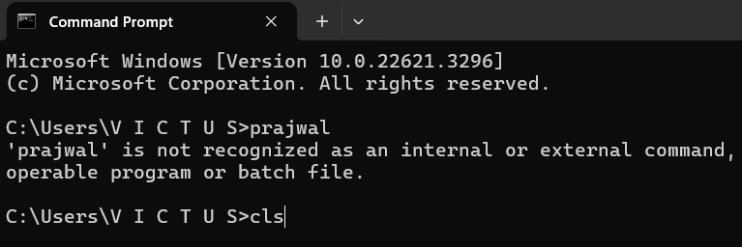

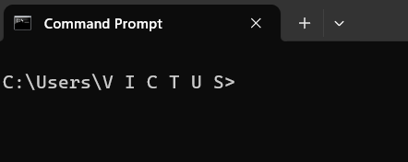

## **5.8 To Display Disk Volume and Windows Version:**

* To open “cmd” then type “vol and ver” after that press enter.

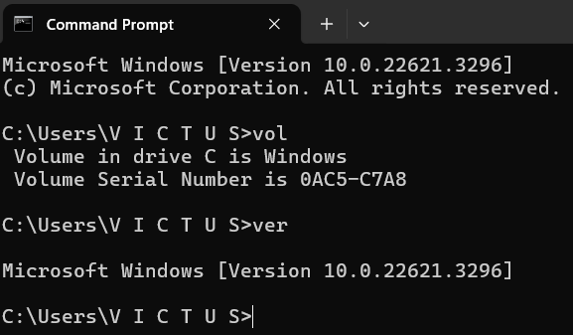

## **5.9 To delete files:**

* At first open “cmd” then type “cd and the path of file for me desktop”.
* Then “write del and file name”.

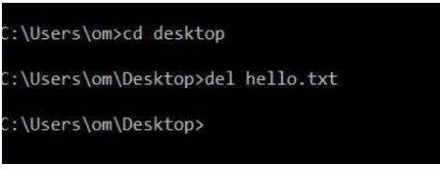

## **5.10 To move a file:**

* To open “cmd”.
* To type “move” and give space “along with the path of the txtfile” then press enter.

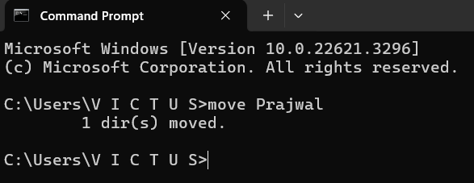

## **5.11 To make copy of a file:**

* **To open “cmd” then.**
* **To type “cd” along with path address.**
* **Then write “copy” and ‘file folder image’ what you want and “path” where you want to copy.**

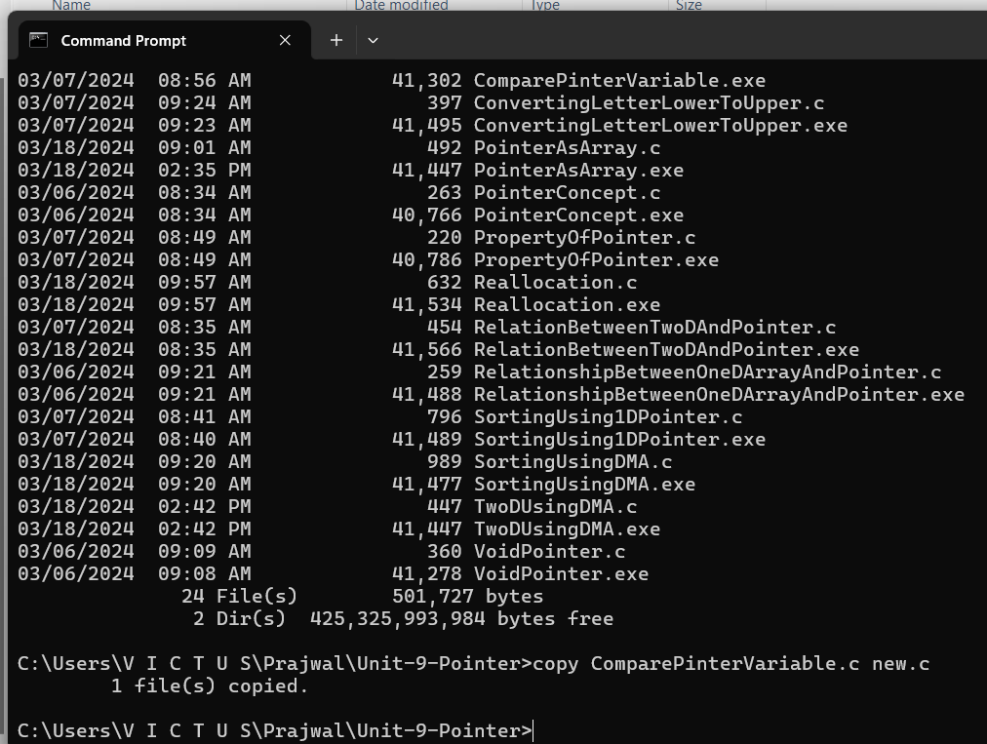

## **5.12 To remove a folder.**

* To open “cmd” and run it as an administrator.
* Then type “cd” and give address along the cd after giving the space.
* To type “rmdir” give a space

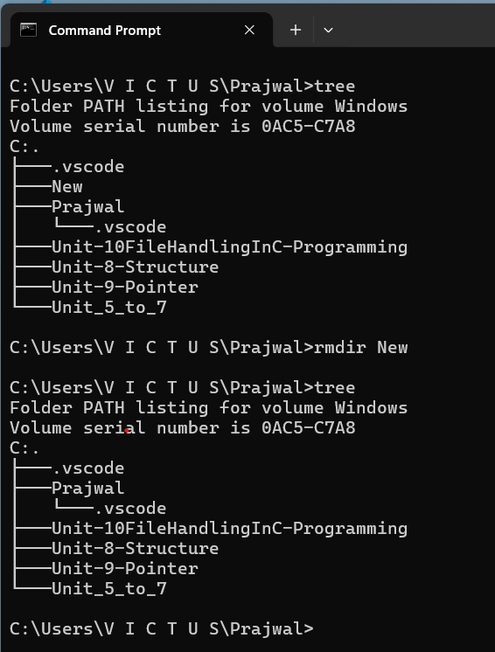

## **5.13 To print our own string on command prompt:**

* To open the “cmd”.
* To type “echo” along with the string you want to print.

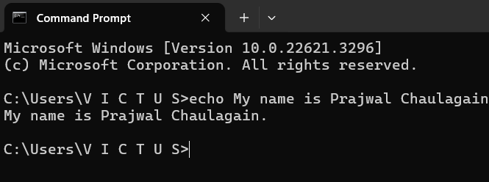

## **5.14 To shut down the computer:**

* To open “cmd”.
* Then type “shutdown /s /f /t 0”press enter.

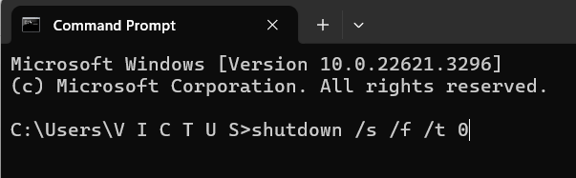

# **6. Feedback of the project:**

Asking for feedback of the email on the following steps:

* At first open the Gmail, then switch to the college mail.
* To click on “Compose” write an email keeping “Ishan Timilsina” as receptionist.
* Then, “Feedback on the subject” was written as the subject of the mail.
* On the body part, feedback was requested.

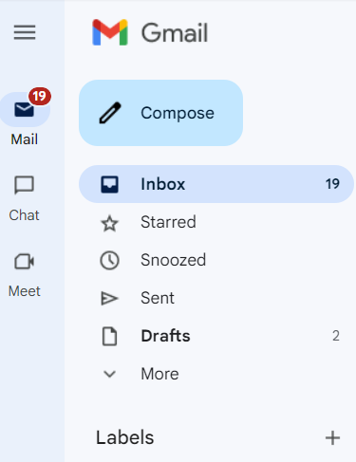

* After that attach the file, then send it.

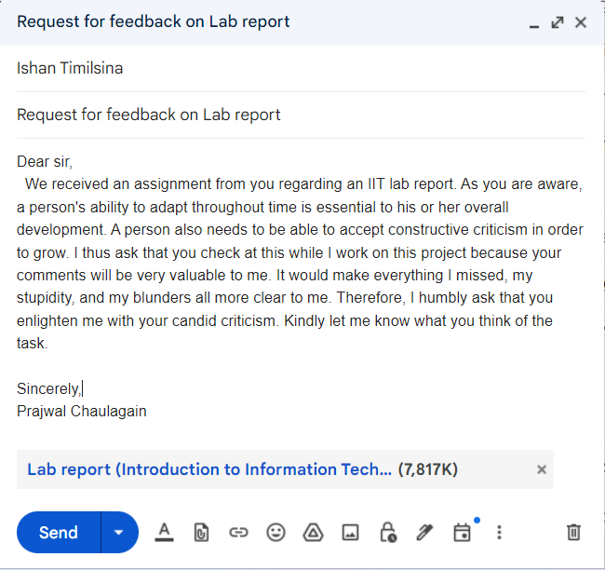

# **7. Conclusion**

This project under the direction of our teacher "Ishan Timalsina" the assignment was completed.   
Examining the fundamental features of Computer Hardware, Microsoft Word, Microsoft Excel, and Microsoft PowerPoint was made much easier by the project. As a result of this study, we were additionally capable of learning Microsoft Dos commands. One type of command-drive interface is Microsoft Dos. The command prompt is still utilized to modify files and data.

This lab report on computer hardware offers a thorough summary of all the different parts that comprise the external and internal hardware of a computer system. An overview of computer hardware is given at the outset of the report, with a focus on how it differs from software and how it is necessary to perform tasks including input, output, processing, and storage. After that, the paper explores the many kinds of computer hardware and divides it into internal and external parts. The motherboard, CPU, RAM, hard drive, SSD, optical drive, heat sink, GPU, and NIC are among the internal hardware components that are covered, along with information about their roles and significance inside the system. Peripherals, or external hardware components, are also described. These include USB flash drives, memory, cameras, touchpads, keyboards, microphones, and other input devices.

The lab reports written on a various topics, including Microsoft Word, Excel, PowerPoint, and Microsoft DOS, show a thorough comprehension of these operating systems and software programs. Every report offers detailed instructions on a range of functions, such as starting the corresponding program, generating documents or sheets, formatting text, aligning content, adding images and shapes, adjusting margins, using drop caps and watermarks, utilizing Excel formulas, and running DOS commands. The reports demonstrate an adept use of the features and resources provided by these software programs to produce organized and aesthetically pleasing spreadsheets, papers, and presentations. The Microsoft DOS operating instructions demonstrate a thorough comprehension of command-line procedures and system features.

The procedure described for requesting email feedback on the project offers a methodical and transparent approach. Using the college mail account after first accessing Gmail guarantees that the right channel is used for communication. Writing "Feedback on the subject" as the subject line of an email to “Ishan Timilsina” makes it simple to understand why the correspondence is being sent. By requesting feedback within the email body, you can be sure that the recipient is aware of the precise information you are looking for. Ensuring that the receiver receives all the materials needed to provide thorough feedback is ensured when the project file is attached before sending the email. In general, adhering to these guidelines guarantees clear communication and encourages feedback sharing, both of which are critical for raising the caliber of the project.

Finally, I would want to express my gratitude to everyone who helped make this happen, especially our teacher “Ishan Timalsina sir”. Learning how to use the many features of Microsoft Word, Microsoft Excel,  
Microsoft Office and PowerPoint. Acquiring knowledge of file handling and manipulation in Linux can be quite beneficial, as Microsoft Dos commands bear similarities with Linux commands. I gained a lot of knowledge about PowerPoint's features, such as animation, from the PowerPoint presentation. I gained knowledge on how to enhance a presentation's interactivity and significance. I need to know how to use Microsoft Excel if I want to work with data and numbers. I was able to employ if-else sentences more efficiently thanks to Microsoft Excel. I want to thank Microsoft for creating such a strong technology that makes even the most jobs easier than before. I have learned a lot from this endeavor, many things that I may have easily missed if I hadn't watched appropriately.

# **8. References:**

Computer Hope. (n.d.). MS-DOS and Windows Command Line Shutdown Command.

Retrieved from Computer hope: https://www.computerhope.com/shutdown.htm

Kaspersky. (n.d.). What is Computer virus and Antivirus and how does it work? Retrieved from What is Computer virus and Antivirus and how does it work?:https://www.kaspersky.com/resourcecenter/definitions/what is Computervirus and Antivirus.

Techtraget. (n.d.). What is MS-DOS(Microsoft Disk Operating System)? Retrieved from What is MS-DOS (Microsoft Disk Operating System)?:

https://www.techterget.com/searchenterprisedesktop/definition/MS-DOS